client-server Model->

Deployment Models for cloud computing->

When selecting a cloud strategy, a company must consider factors such as required cloud application components,

preferred resource management tools, and any legacy IT infrastructure requirements.

cloud-based deployment model->

In a cloud-based deployment model, you can migrate existing applications to the cloud, or you can design and build new applications in the cloud.

You can build those applications on low-level infrastructure that requires your IT staff to manage them.

Alternatively, you can build them using higher-level services that reduce the management,

architecting, and scaling requirements of the core infrastructure.

why company should use them.-->

Upfront expense refers to data centers, physical servers, and other resources that you would need to invest in before using them.

Variable expense means you only pay for computing resources you consume instead

of investing heavily in data centers and servers before you know how you’re going to use them.

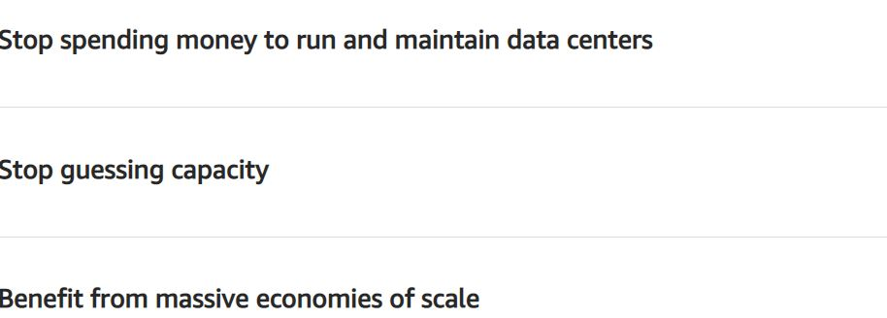

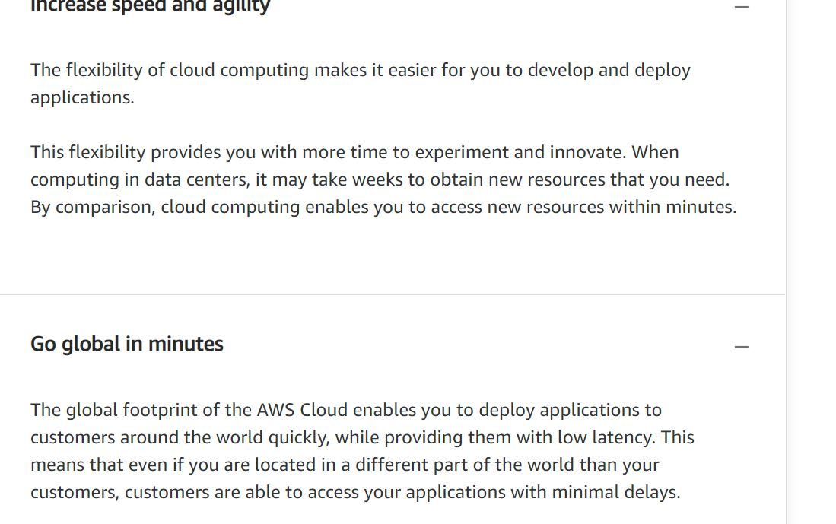

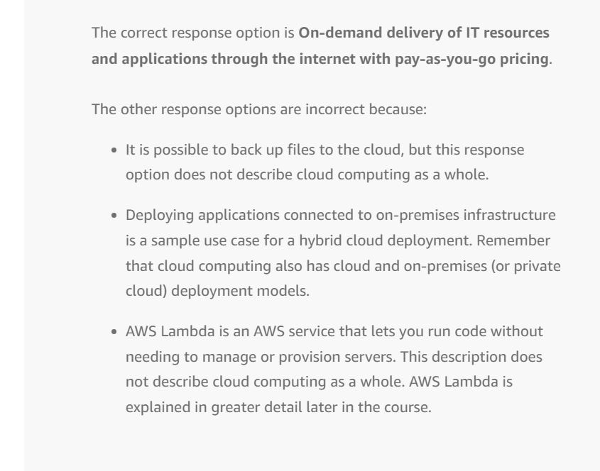

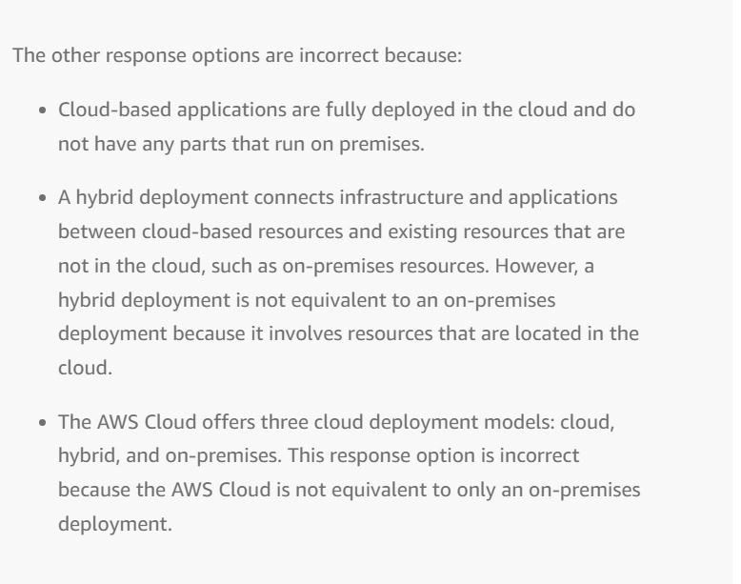

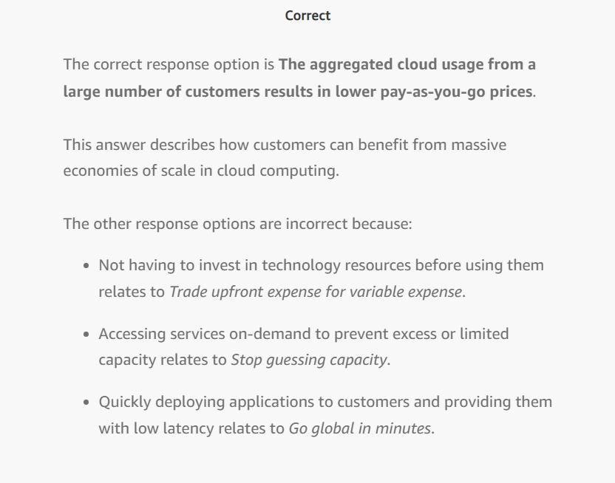

EC2->while there is any demand , client needs to call the server i.e. virtual server which further calls the another server named EC2,running on server is highly flexible, cost effective and quick.

It is very difficult to use servers and you have to get heavy purchase before using and it will be better if you pay for what you are using i.e. Running instances only.

In this we are sharing our resources with the other with other virtual machine, Hypervisor is responsible for discriminating among the virtual machines i.e EC2 instances are secure even when they are sharing the resources.

One EC2 instance is unaware of other Ec2 instance on same host,even when they are similar to each other.this is **MULTITENANCY**

**E**c2 provides flexibility and control on configurations.

Ec2 instances are resizable.

EC2 provides compute as a service Model.

Ec2 are of different types and each type has different strengths and capabilities and its upto the user to choose which EC2 instance he wants.

Types of EC2 instances are->

* General purpose(balanced resource, web servers, code repositories)
* Compute optimized(compute intensive tasks, gaming ,scientific modelling)
* Memory optimized(memory intensive task)
* Accelerated computing(floating point number calculation, graphic processing, data pattern matching, utilize hardware accelerators)
* Storage optimized.

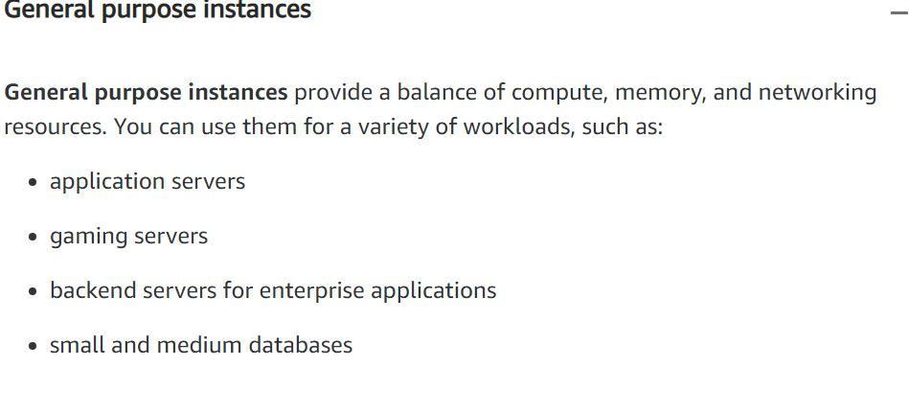

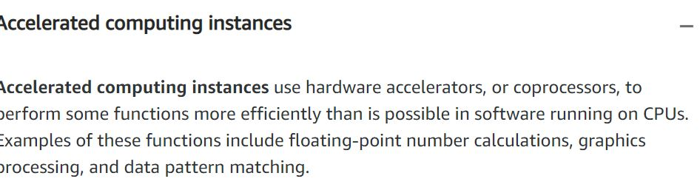

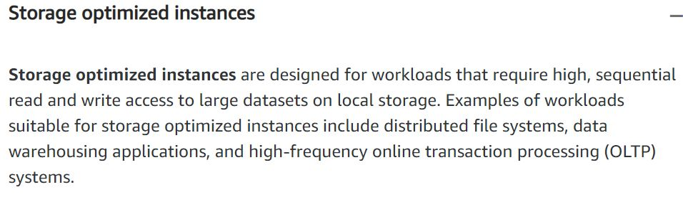

## **Amazon EC2 Pricing**

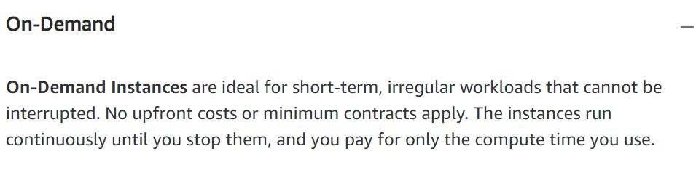

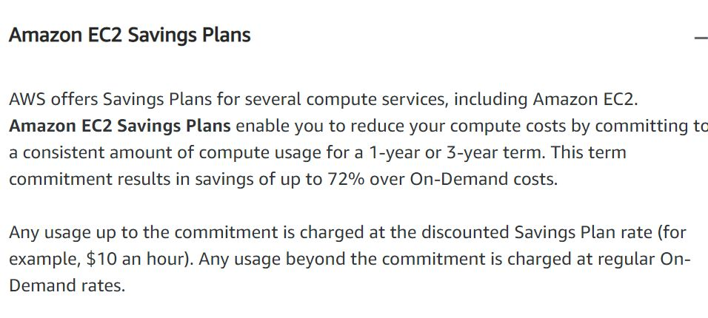

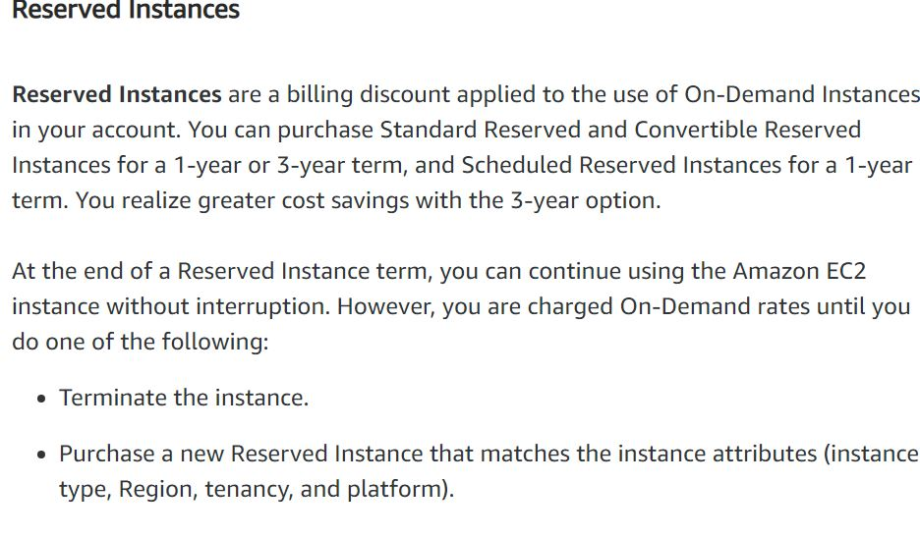

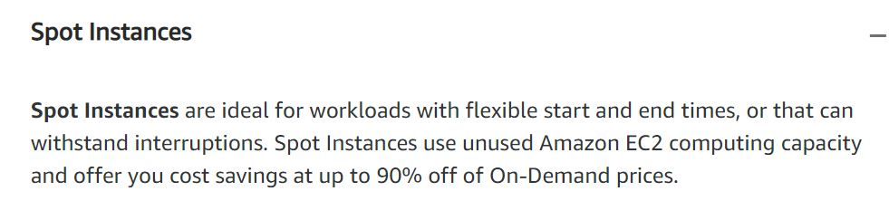

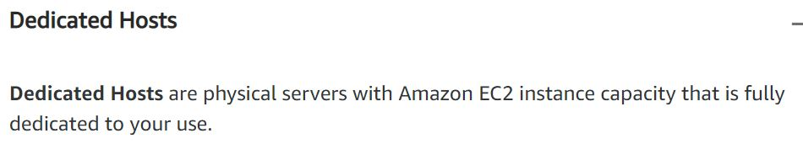

## Scaling Amazon EC2

**Scalability** involves beginning with only the resources you need and designing your architecture to automatically respond to changing demand by scaling out or in

If we take avg capacity the ,business fails at peak, but if plan for peak still the resources are wasted, so to avoid this demand scenario AWS is a best choice.

With Amazon EC2 scaling ,two types of scaling-Dynamic scaling(responds to changing demand)

Predictive scaling(Right number of Ec2 instance based on predicted demand).

Scaling up basically means that you are increasing the strength of order taker which is practically useless.to work as per demand you need to increase number of instances and service providers as per demands.

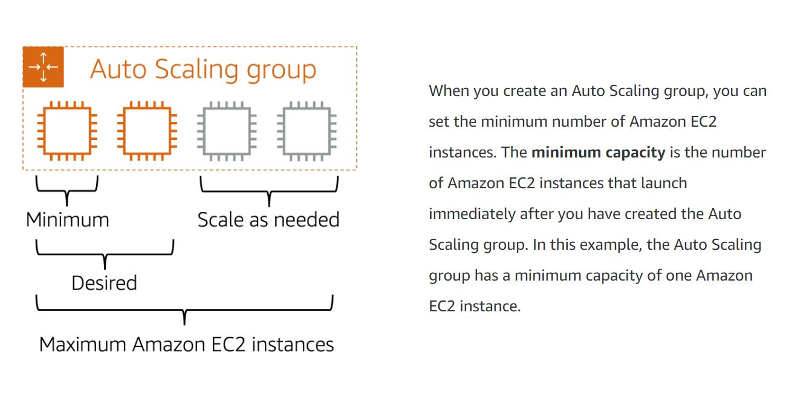

It is possible to handle traffic manually as per demand, to make (1) high performance

(2)cost-efficent (3)highly available (4)Automatically Scalable

Elastic Load Balancing ->

Is a region level so services are highly available at your part, as the traffic increase the resources for ELB increase automatically without any extra cost.

As traffic increase autoscaling service let it know the load balancer that it is now available to handle traffic…as the traffic released the instances are automatically terminated after the fulfilment of service.

A load balancer acts as a single point of contact for all incoming web traffic to your Auto Scaling group. This means that as you add or remove Amazon EC2 instances in response to the amount of incoming traffic, these requests route to the load balancer first. Then, the requests spread across multiple resources that will handle them.

Tightly Coupled Architecture->if Application A sends message directly to Application B directly, in case of Application B failure there would be problem with application A as well.

Loosely Coupled Architecture->single failure won’t cause cascading failures throughout the whole system. Means if the Application B fails for the time the message are remain stored in the queue and the message will forwarded to application B as the message revokes.

Two queue services are->

1.Amazon SQS(Simple Queue Service)

2.Amazon SNS(Simple Notification Service)

In a microservices approach, application components are loosely coupled. In this case, if a single component fails, the other components continue to work because they are communicating with each other. The loose coupling prevents the entire application from failing.

When designing applications on AWS, you can take a microservices approach with services and components that fulfill different functions. Two services facilitate application integration: Amazon Simple Notification Service (Amazon SNS) and Amazon Simple Queue Service (Amazon SQS).

**Amazon SNS**🡪Publisher pushes the message to the subscribers as cashier message to the workers. we can get message by sns for small works(specific process) within a big task(goal).

subscribers can be web servers, email addresses, AWS Lambda functions, or several other options.

**Amazon SQS**->You can send store and receive messages between components without losing messages and other services to be available.

. In Amazon SQS, an application sends messages into a queue. A user or service retrieves a message from the queue, processes it, and then deletes it from the queue.

why is SNS better than SQS in aws?

SNS is typically used for applications that need realtime notifications, while **SQS is more suited for message processing use cases**. SNS does not persist messages - it delivers them to subscribers that are present, and then deletes them. In comparison, SQS can persist messages (from 1 minute to 14 days).

Even if EC2 is flexible,reliable,scalable it takes lots of proper management of EC2 instancing,patching in software enivornment, hosting in proper enivornment and lots of manageable stuff.

AWS offers multiple serverless options, means you can see the underlying infrastructure,main purpose is take care for your application and rest is taken care off.

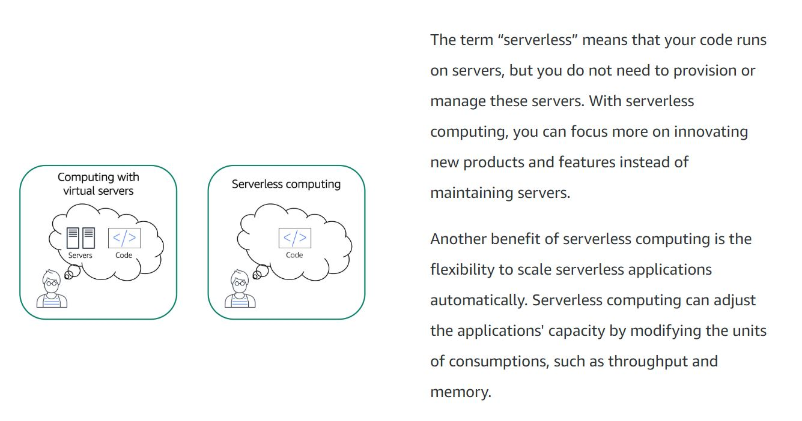

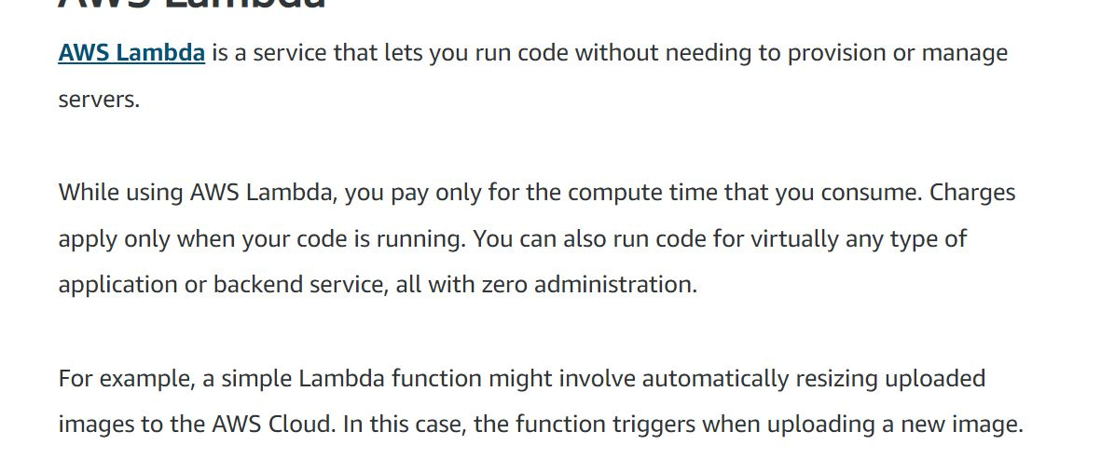

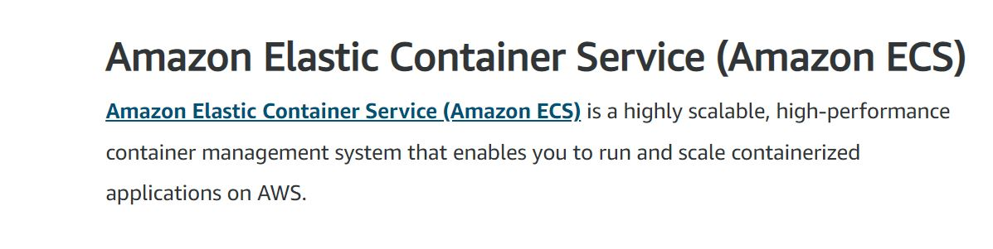

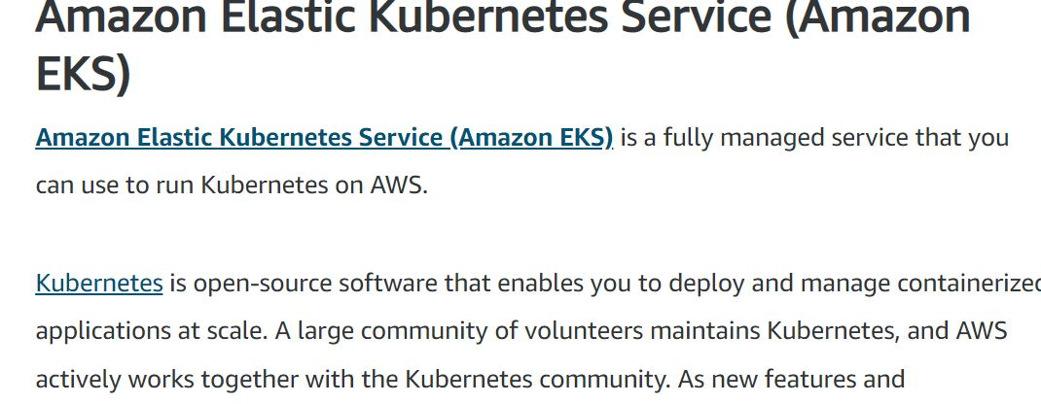

AWS lambda allows you to upload your code, what you say it as Aws lambda

If you have 1000 triggers ,lambda will help to meet demand, it is not for long processes like deep learning, it is basically for web development on the whole. i.e less than 15 s to complete.

Amazon ECS(Amazon Elastic Container Service) and EKs(..Kubertenes service)-🡪these are container orchesteration tools

Docker is platform having os level virtualization.you

multiple EC2 instance,form cluster…this is orchestration. orchestration tools help to manage containers

Eks does the same thing but with different tooling and different features.

If you don’t want to mange instances a lot ,you can use AWS Fargate is a serverless computing platform either ECS or EKS

* If you want to use host traditional applications, full access to OS use EC2.
* If you want to host short running functions, service oriented application, event driven application ,no provisioning or managing serves go for AWS Lambda.
* If you want to run container based workload on Aws can choose Amazon ECS or EKS

Availabilty 🡪is what actually matters i.e we have multiple data centers where we can locate our servers with respect to demand.

Compliance 🡪AWS assures that if you want your data to be always in your country, no issues it will remain there and can only be exported with the prior permission of the sender.

Proximity ->If you don’t have any compliance issue then you can go for other factors. Such as proximity which means that data center must be close to customer as it is closer and latency(response time) will reduce if data center is closer to customer.

Feature Availabilty -> some new features are not available at particular data center ,so it take some time to make it available to a particular data center.so some demand cannot be fulfilled at particular data center.

Pricing- as in some countries price is different as per taxes , so the aws charge differently as per region and services.

Elastic load balancer runs on all availability zone, not on single availability zone.

An **Availability Zone** is a single data center or a group of data centers within a Region.

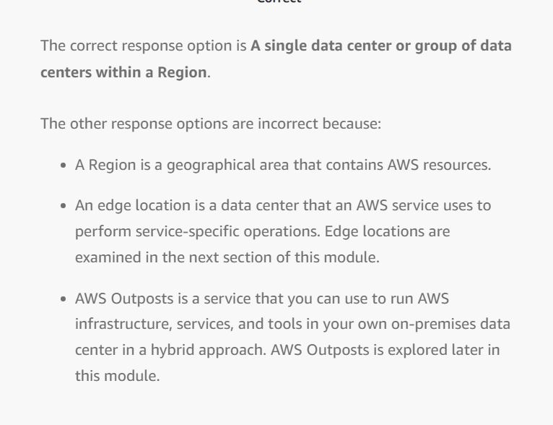

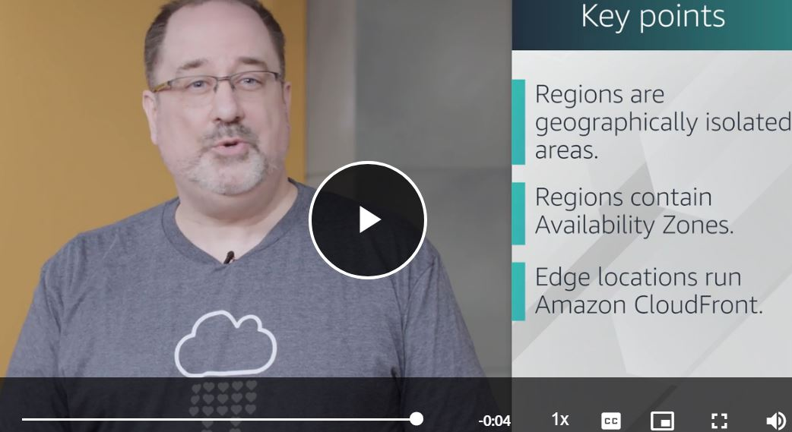

An **edge location** is a site that Amazon CloudFront uses to store cached copies of your content closer to your customers for faster delivery.

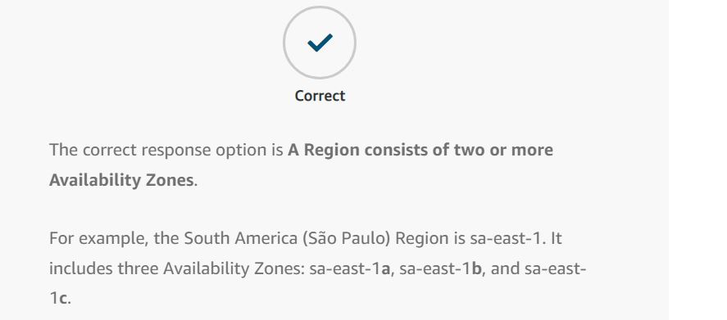

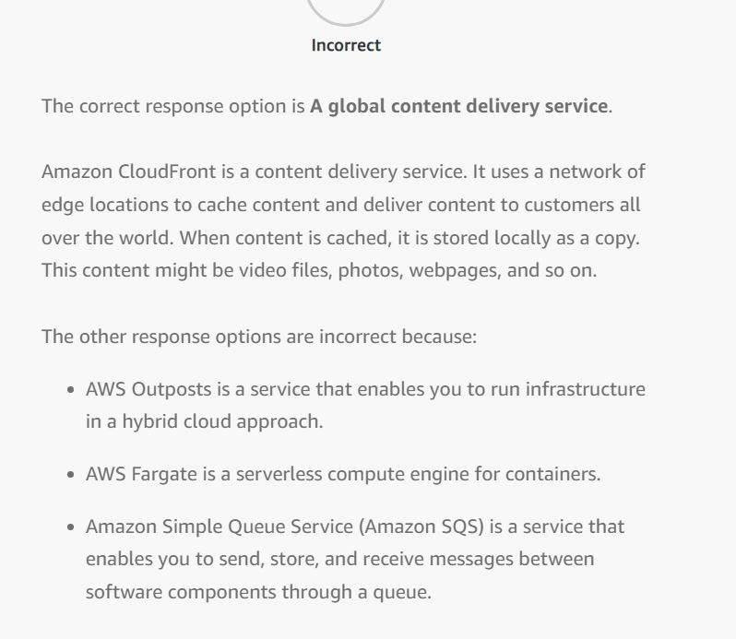

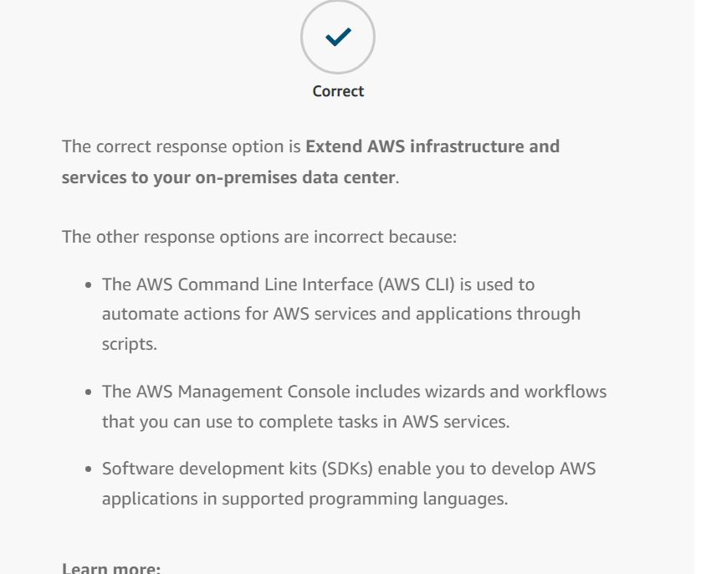

VPC :- provides logically isolated section of AWS cloud where we can launch AwS resources. These can be public facing with internet or private facing without internet. public and private grouping of internet resources is termed subnet. And there are number of IP address in your VPC.

If we want some resources to interact with customer, we put it in the public VPC, if not we will put it in the private VPC.

VPC is virtual private network in the AWS. It allows you to define your range for private internet resources. you can place EC2 instances and ELB resources inside your VPC.

Internet gateway is like a door where no person can go without it like a gateway. we don’t need internet gateway as door but we need virtual private gateway to enter into a VPC, it is like a door only allowing the data through private network,not through a public network.

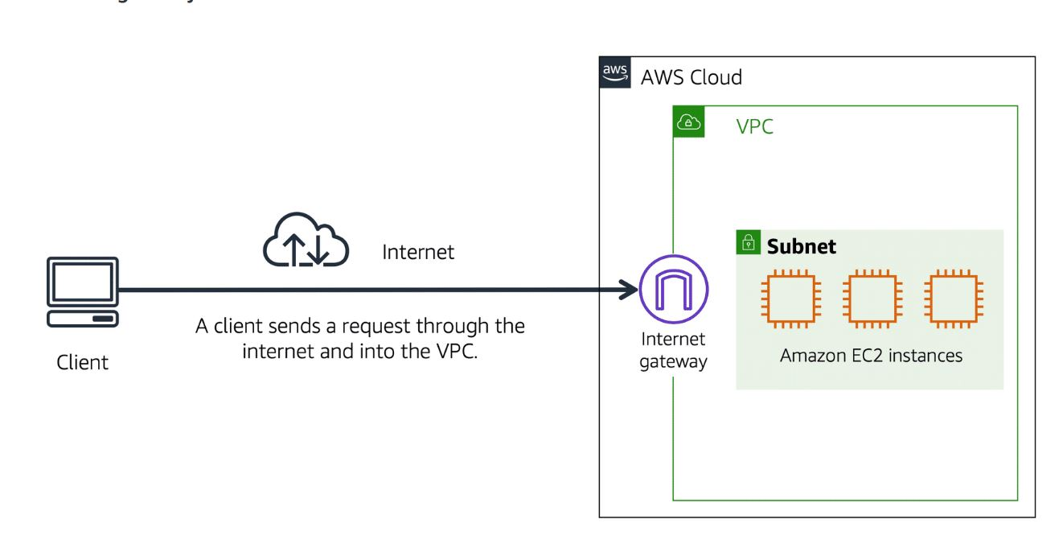

VPN->

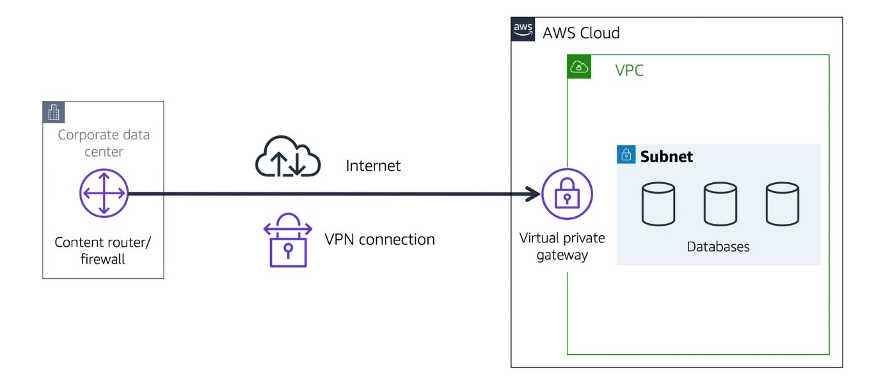

If you want VPN TO AWS RESOURCES,YOU need to attach virtual private gateway to VPC.

VPN is good way to connect to AWS directly, but it still face some network traffic issues while going since it share network bandwidth with the other internet as well, causing traffic so the solution is **AWS Direct Connect**.

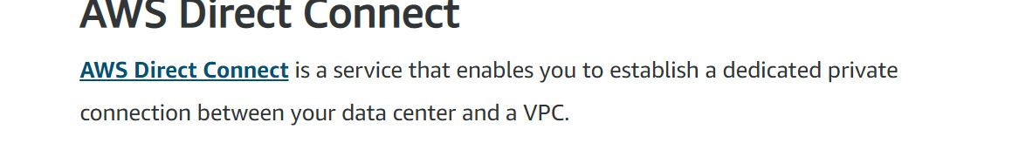

AWS connect your client directly to VPC.(direct doorway).



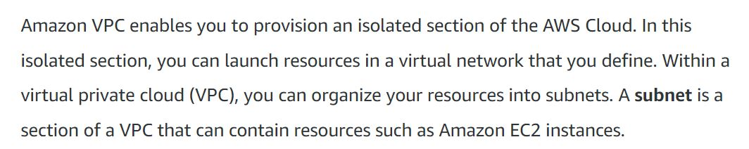

AWS had wide variety of tools such as

1. Network Hardening (In vpc network ACL’s basically take the charge to check if the packets passing through the network are legitimate, if not, rejected directly ).
2. Application Security
3. User Identity
4. Authentication and Authorization
5. Distributed Denial Of Service Prevention.
6. Encryption

There are several packets and packets are checked across Network access control list, after this the packets are checked from Network ACL’s, if you are on the approved list ,you move ahead and if you are on do not enter list, you are rejected.

Each subnet has multiple instances with in it.so each instance is protected by the security group, which accepts the specific type of messages.

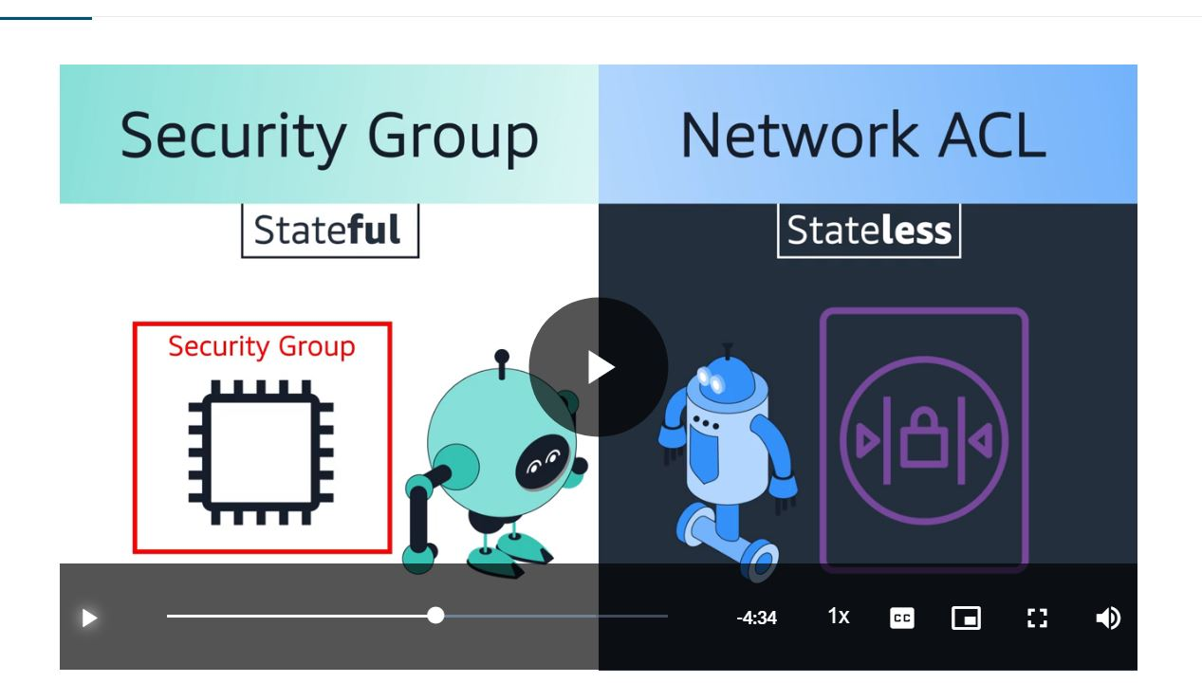

Difference between security group and acl is security group has some sort of memory where as acl does not have memory. These basically do not check what is in the packet they check that sender must be in the approved list.

subnet 1 subnet 2

ACL

ACL

Security grp

Security Group

The packets need to pass all guarsds to move from instance1 to instance2.

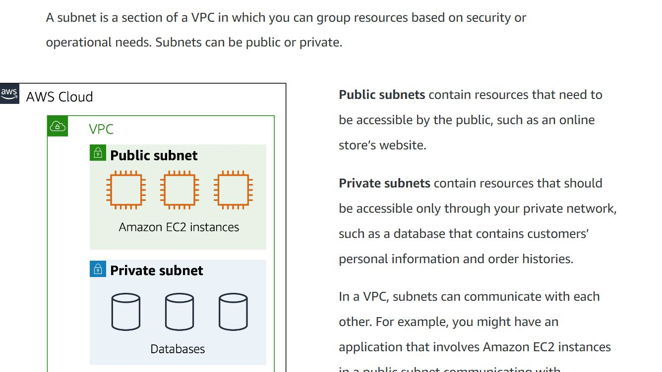

For webhosting AWS provides two services

1)**Amazon Route 53 is** amazon Domain name Service or DNS is highly available and scalable service ,think DNS as translation service, used to convert Domain name into a IP address ,that computers can read. if you add Domain name, it contact Amazon Route 53 to find the IP address of the site.then it routes your computer to a browser or address.

Amazon Route 53 routing policies

1)Latency based Routing

2)Geolocation DNS

3)GeoProximity Routing

4)weighted RoundRobin

2)**Amazon cloudFront ->**

Content Delivery network:-network that delivers edge content to users based on geographic location.

If you want to access website the origin of datacentre must be as close as possible to improve the latency. But if someone from other origin also want to access website data must be as close as it can here come the concept of cloudFront which instantly copies the data on closer origin.

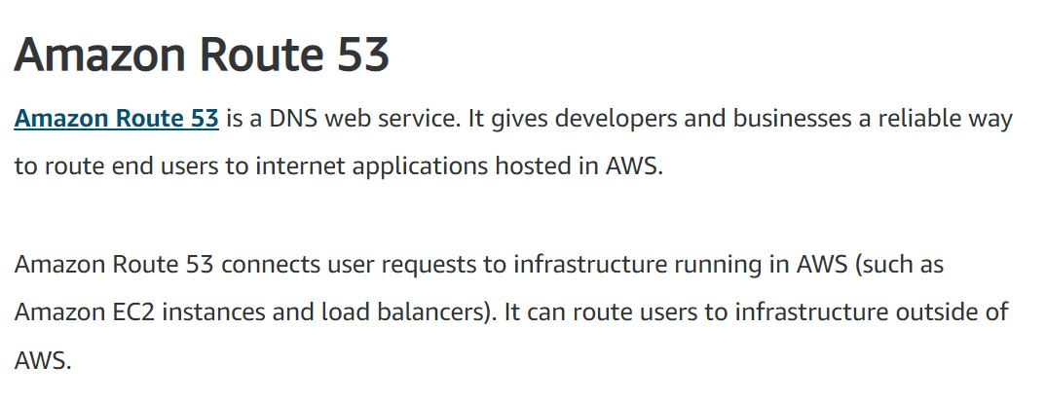.

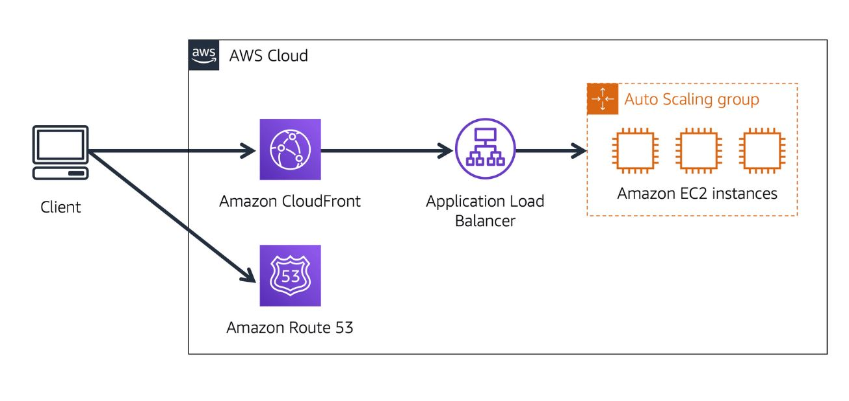

We need to have perfect databases and storage according to our needs. we need to have perfect data solutions.

Instance Store and Amazon Block Store ->

EC2 provide access to cpu , network,memory,storage.

EC2 instances have hard drive as well it is of few different types, it provides with instance store volumes.it works on hypervisor AWS host and Instance store volumes.

If you stop EC2 instance the data in EC2 instance will be deleted. The Reason for this is if you start from the stop state it is likely to start EC2 instance on other host.

Don’t store data within EC2 instance drive because complete data will be deleted on stopping the Ec2 instance.

Amazon EBS(Elastic Block store ) VOLUMES->THESE ARE drives outside EC2 instance volumes ,it is directly tied to the host on which EC2 is running on.

EBS volumes can process on the starts and stops of EC2 instance.

You define size type and configurations of the volume you need and then attach it to EC2 instance.

If you start and stop EC2 instance the volume in the data remains. EBS allows you to take snapshots regular basis, so that if drive is corrupted it can be recovered then and there itself.

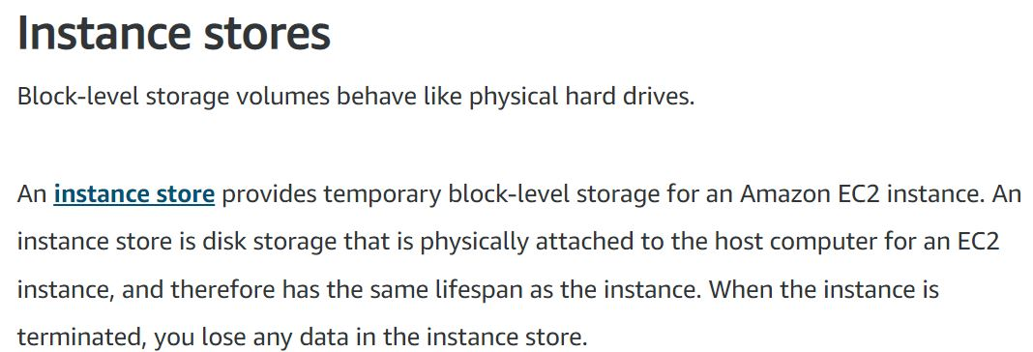

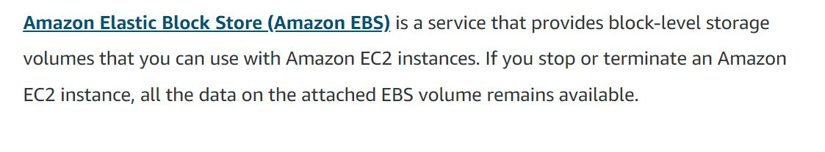

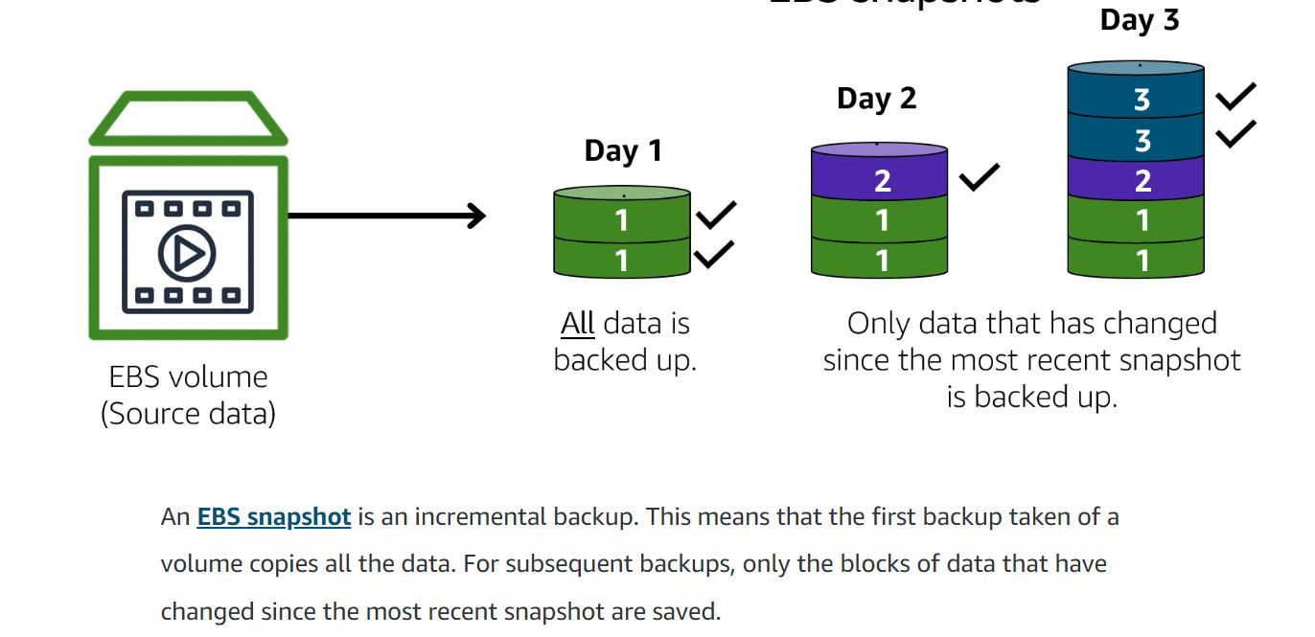

## Amazon S3->

It is basically used to store and retrieve unlimited amount of data at any scale.

* In Amazon S3 data is stored as objects.
* Store object in Buckets.
* Upload maximum object size of 5TB.
* Version Objects.
* Create Multiple Buckets, you can even stage data between different tiers.

## S3 standard->

First Tier comes with S3 standard ,if you store it in first tier it has 99.999999999% of durability i.e. it will remain intact after year is very high. Data is stored in three facalities, data is stored in two concurrent facilities. Files are stored in multiple availability zones.

* One way to use S3 is **static website hosting.**
* **Amazon S3 IA –infrequent access**-> it is a place where there is storage class,it is used when there is a data to be stored for several years and we do not need it frequently.

## Amazon S3 glacier ->

We can use Amazon s3 glacier to archive that data.

Amazon S3 vault lock-> you can add WORM (write once Read Many) and lock the policy from future edits ,once locked policy cannot be changed in the future

Amazon S3 Lifecycle Management🡪used to move data automatically between tiers.

***if you want to change tier from S3 to IA after 60 days and to want to get it back to S3 after 30 days, no issues you can do it easily by writing a policy.

There are also storage classed s3 storage deep archive as well as Infrequent Access 1 zone which can be used.

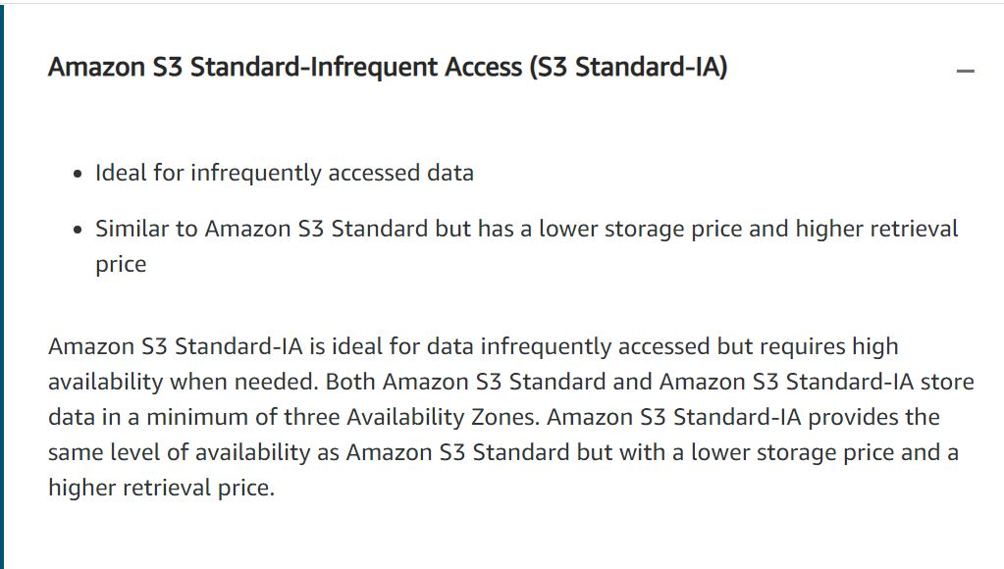

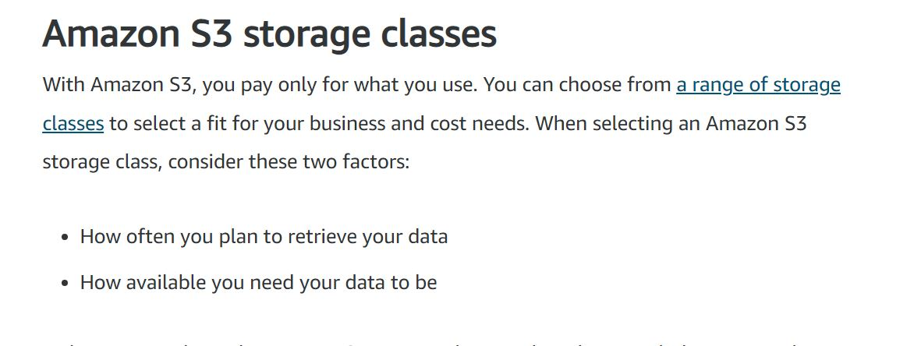

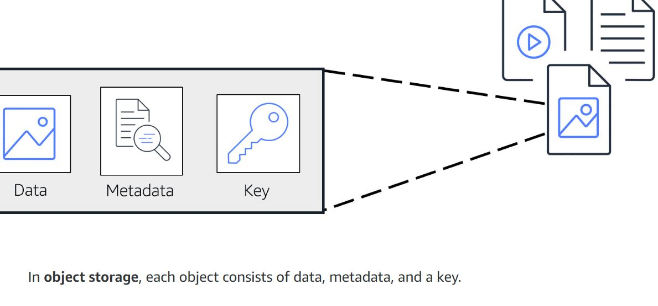

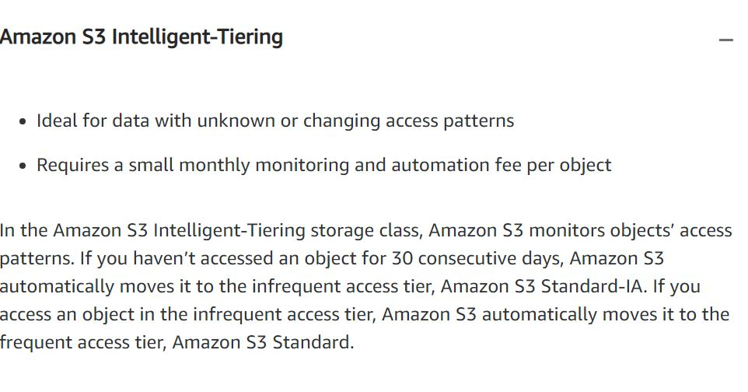

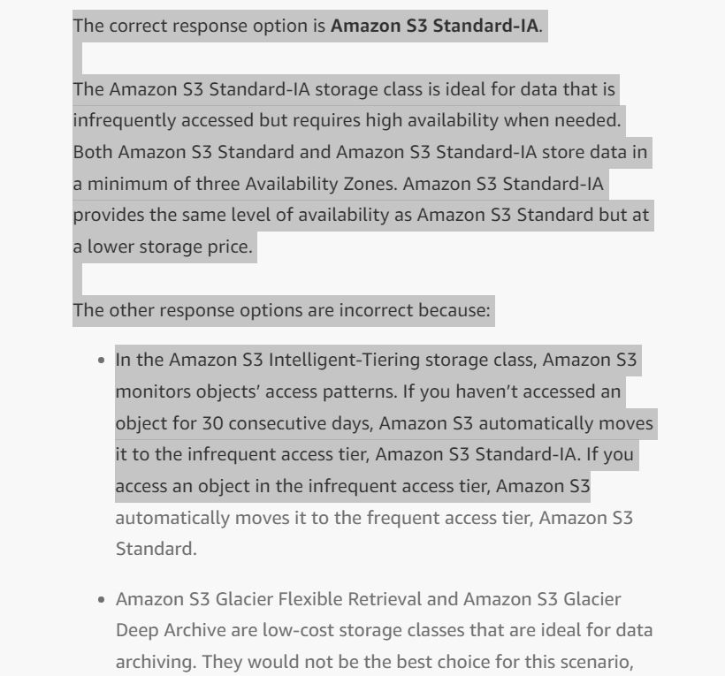

# **Amazon EFS(Elastic File System)->**

EFS is a managed file system, it allows multiple instances to access data at the same time. It scales up and down automatically as needed without managing that scaling .

Difference between Amazon EBS and Amazon EFS

EBS EFS

* Multiple instances reading and writing simulataneously.
* It is a Linux File System.
* It is a Regional Resource i.e any EC2 instance in region can be related to file resource.
* Automatically scales.
* Volumes are attached to EC2 instances.
* Availabilty zone level Resource.
* Need to be in same availability zone to attach EC2 instance.
* Volumes do not automatically scale to give you more storage.

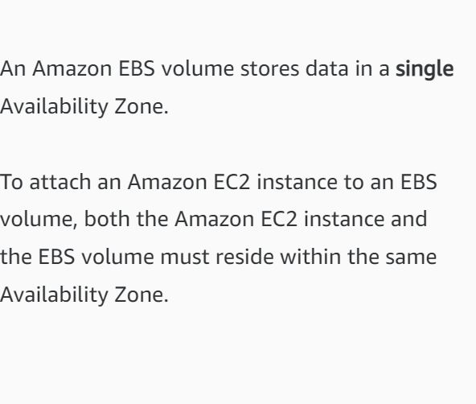

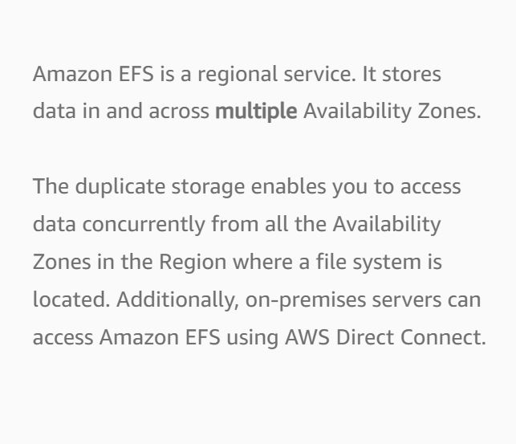

If you want to keep track of relationship between customer and business, so it is best to use Relational Database Management System.

AWS supported databases are –>

* MySQL
* PostgreSQL
* Oracle
* Microsoft SQL Server.

Is there any way to move them to cloud yess.. ..By Lift and Shift Migration.

And Run on amazon EC2.The other way to run to run your database on cloud ,we use Amazon Relational Database Service.

It support all the managed database service.

Amazon RDS is used for

* Automated Patching
* Backups
* Redundancy
* Failover
* Disaster Recovery

It allows you to focus on business problems and not maintaining servers.

How to Make easier to run database workloads run on the cloud.-use **Amazon Aurora.**

it comes in two forms MySQL and PostgreSQL.

It costs 1/10th cost of commercial databases, Data Replication

Amazon Aurora🡪

Continuous backup to Amazon s3.

Point in time Recovery

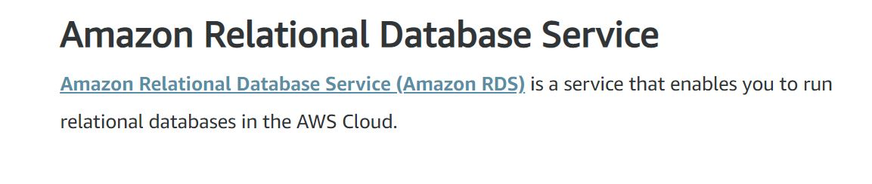

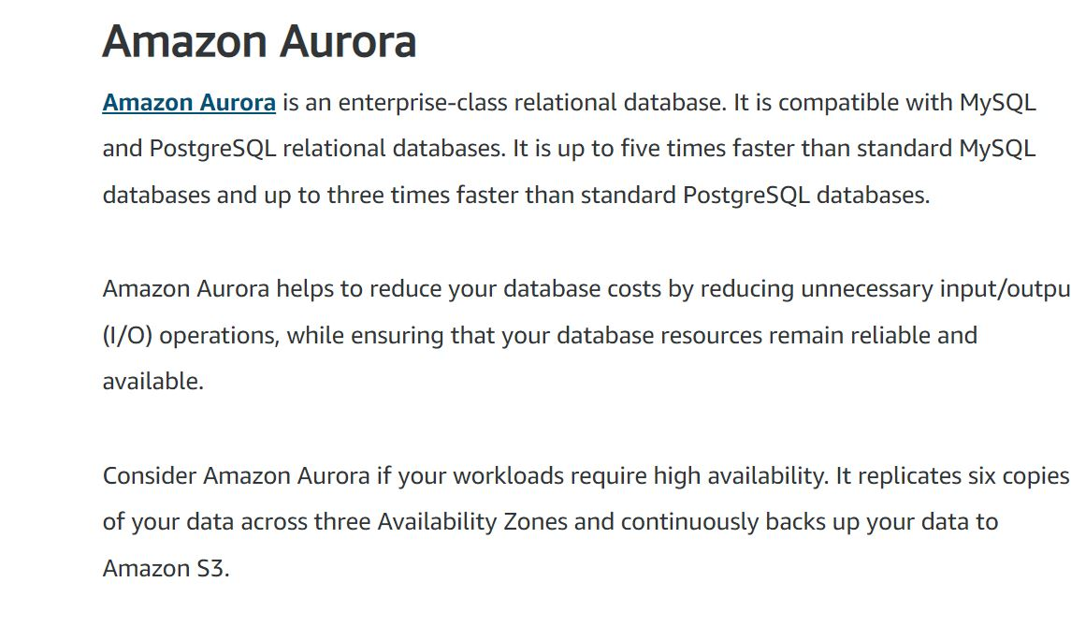

Amazon DynamoDB-> A Serverless database ,it you have one attribute or thousands of attribute amazon dynamoDB is responsible for managing underlying instances for you. you do not need to worry of scaling of your system up or down.

Dynamo DB is highly available because of its availability in diff. availability zones. DynamoDB is highly available and performant data .it works on seconds of response time.

DynamoDB is a non-relational database, they have Simple flexible Schemas not Complex Rigid Schemas with DynamoDB you can add or delete the elements from the table anytime. not every item items have same attributes ..Datasets have some variation from item to item, you cannot implement SQL queries on it directly instead you have to implement tthequeries on the certain attributes designated as keys.

Because of this normalization of table becomes simpler and is focused on one table not multiple table.it increase response time for DynamoDB and highly scalable.

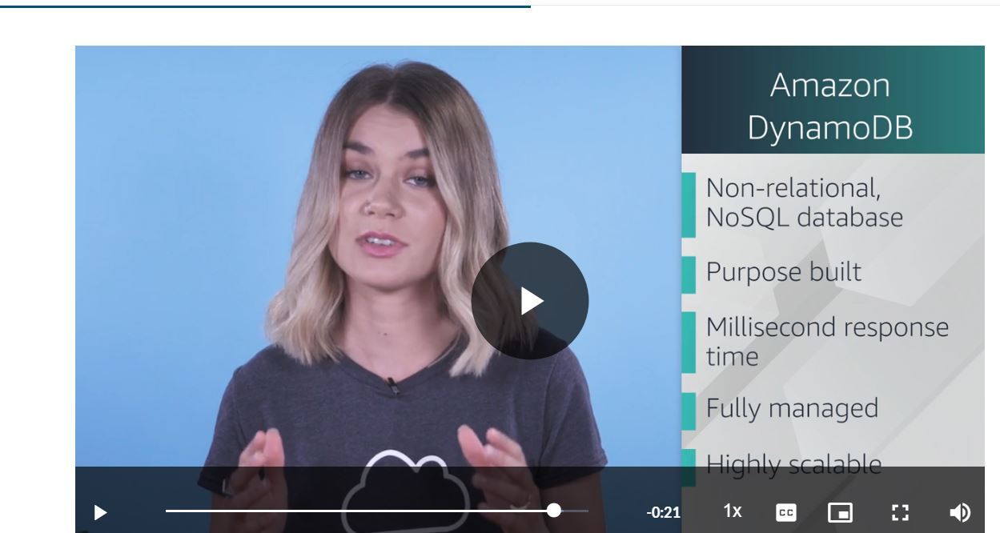

Amazon RDS and Amazon DynamoDB use depend upon test case Scenarios as in sales business anaylytics you have go through complex relationship between tables we use Amazon RDS.

But In case of employee table ,details of employee …Amazon DynamoDB is champion.

## Amazon RedShift ->

Database that can handle thousands of transactions per second stores that is highly available and efficient but some time we need to go from what actually is happening to what actually happened earlier in the past. for now in the field of IOT there is lot of data and it seems difficult to handle such data and here comes the concept of datawarehouses.

Datawarehouses are engineered specifically for this kind of big data, where you are looking for historical anaylysis of data as supposed to operational anaylysis.

Like as if you are selling coffee ,any number of coffee could be sold any time, so you always have to put a check on historical data for anaylysis.Data ware house is the best solution for that.

It would be good if your data warehousing team focus on the data instead of taking care of engine and handling large data for that we have redshift which is used for big data BI solutions and is used by Single API call.

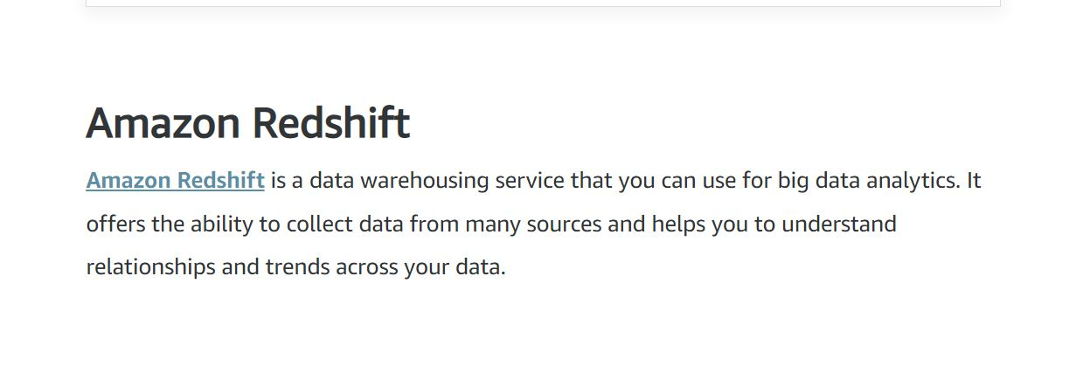

**Amazon Database Migration Service(DMS)->**

if you have database already in the cloud and we need to transfer it to AWS for this we have one magical service to migrate it to the cloud, we have Amazon Data Migration Service.

We can transfer data from source database to target database, source database will remain operational even after migration.

* Downtime is minimized for those who rely on that database.
* Source and target database don’t need to be of same type.

i.e

MYSql server

## 

Oracle server

Amazon RDS

Microsoft SQL Server

Because Schema Structure, Data types, Database Code must be same between source and target.

## Homogenous DB

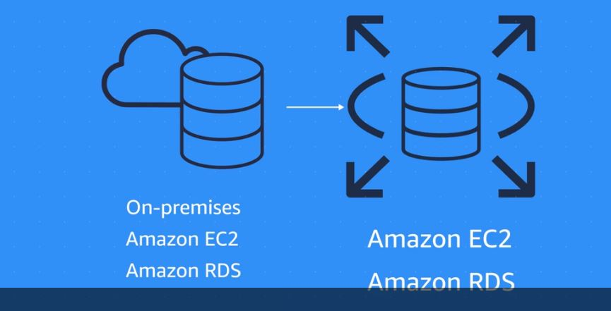

## Heterogenous DB ->

It is a two step process

As Schema Structure, Data types, Database Code are different we need to convert the schema among the tables using AWS schema conversion tool, is a part of heterogenous db to convert source schema and code to match target database.

Then we use DMS to migrate from source DB to target DB.

Other uses of DMS are

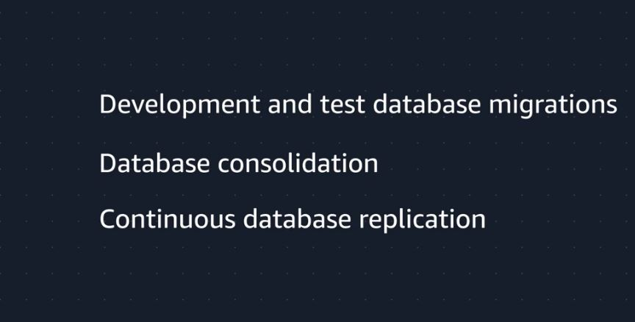

1 Development and test database migration 🡪used when you transfer your data from database to test environments.

2.Database consolidation 🡪when you have many database and want to consolidate multiple database to single database.

3.Database Replication🡪we want to recover data in disasters.

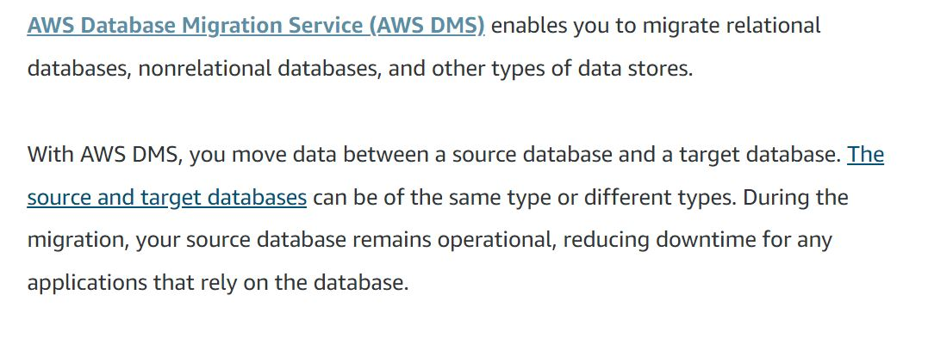

Choosing Right Database is what we actually need🡪there are many other databases that AWS provides.one database cannot fit all the scenarios there are multiple databases as per requirement.

1.Amazon DocumentDB🡪great for content management catalogs ,userprofile etc.

2.Amazon Neptune🡪great for social links or graphical management who is connected to whom.great for fraud detection ,supply chain.

3.Amazon managed Block chain 🡪if you Block chain financial solutions and all,immutabilty etc. we have this feature to work upon it.but it is a part if we want better solutions it will be better Amazon **QLDB.**

**4.**Amazon QLDB🡪Immutable System of records where any entry can never be removed from an orders

Databases are great but we want some better speed we have **database accelerators**,if we apply o caching layers on databases ,it reduce speed from millisec to microsec ,improve the read time of the requests.

**Amazon ElasticCache** provide caching layers , if using DynamoDB u can use **Amazon DAX** used to improve read time for normalized data. AWS want to make sure u use best tool for the job.

## Security ->

We need to discover various security mechanisms we offer on the AWS Cloud, like shared Responsibilty model i.e.

AWS is responsible for security of the cloud, customer responsible for security in the cloud.

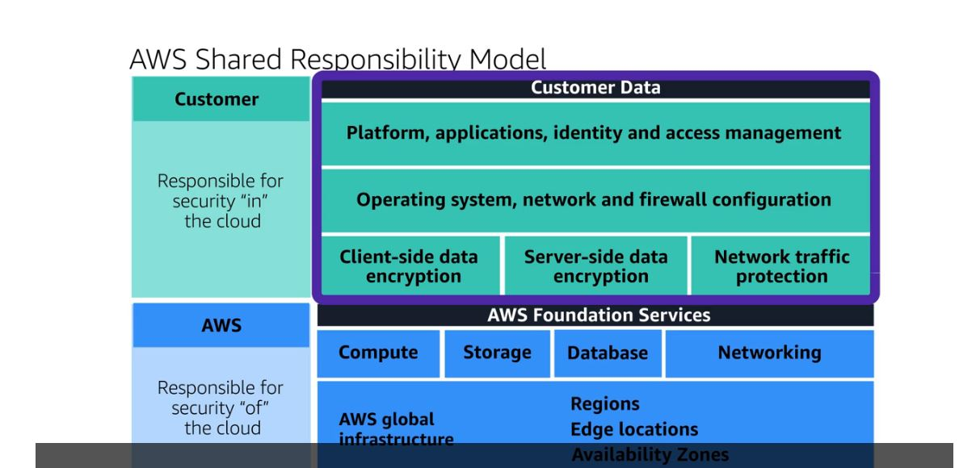

Who is responsible for security in the cloud🡪

1. Customer

2. AWS

Answer is both are responsible for security in the cloud. As Aws we look your environment as a group of objects some the objects aws are responsible but for some objects customer are responsible 100%.

AWS is responsible for some of the security->

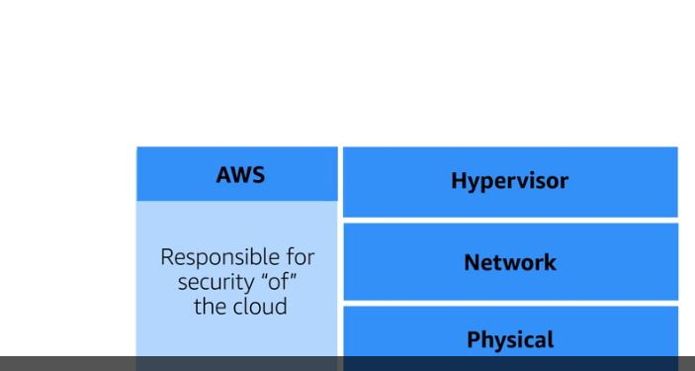

Like as home Aws is responsible for wall,windows, door but it is your responsibility to lock the door.AWS do not have access to keys of your lock.

If AWS found some vulnerabilities with window aws can notify, but we cannot actually deploy a patch i.e no one can deploy anything that might break your system accept your team.

You can run whatever applications you want, you own them, you maintain them that owns part of your stack i.e data.

AWS provides everyone with the toolset they need to provide access to authorised person or no one as per need. AWS is responsible for security of the cloud and you are responsible for security in the cloud.

Customers are responsible for the security of everything that they create and put in the AWS Cloud.

AWS is responsible for security of the cloud.

AWS operates, manages, and controls the components at all layers of infrastructure. This includes areas such as the host operating system, the virtualization layer, and even the physical security of the data centers from which services operate.

IAM policy🡪is a document which defines what api calls can user make or cannot make.

Effect: Either Allow or Deny; Action: Any AWS Api call

One way to organize permissions is to organize in IAM groups. you can attach policy to that group and all persons in that group have permissions.

You can create identities in AWS called Roles.

# AWS IAM ROLES🡪

* Associated Permissions.
* Allow or Deny
* Assumed for temporary amount of times.
* No Username or Password.

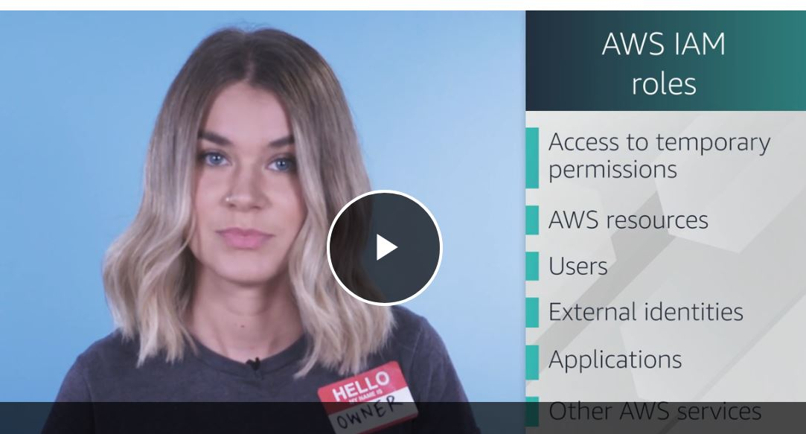

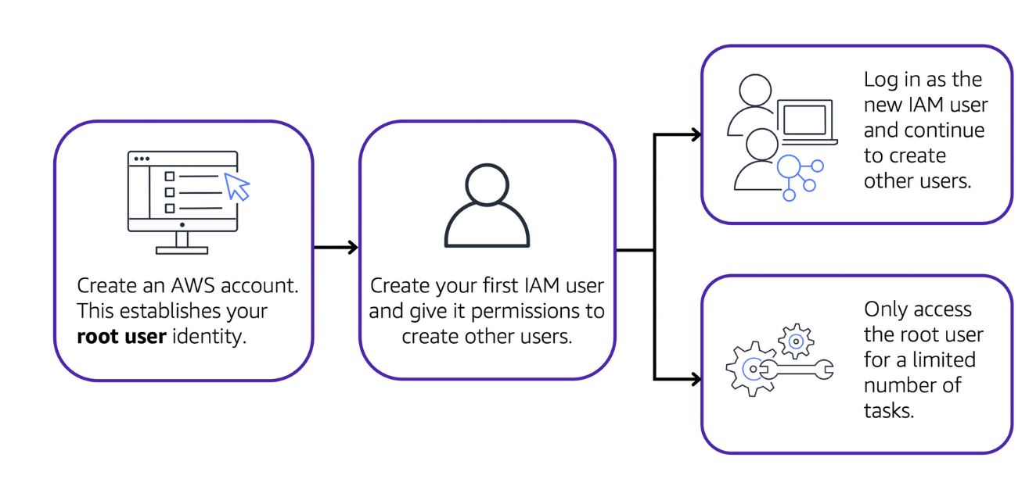

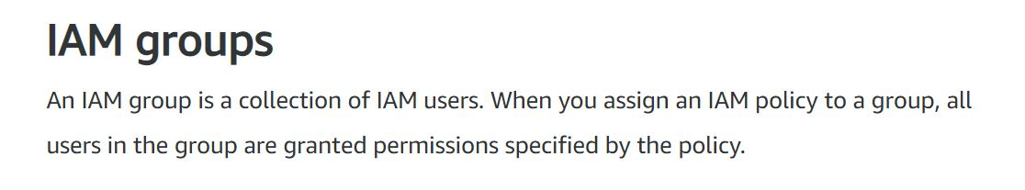

# AWS Organisations🡪

A Central Location to manage multiple AWS Accounts is AWS Organisations.

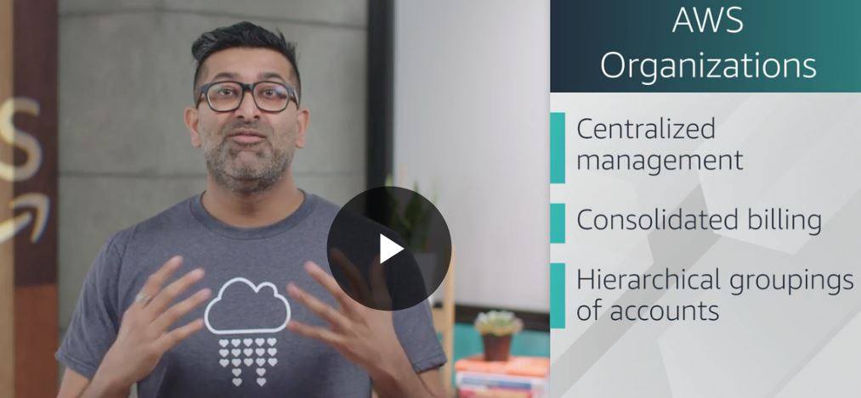

AWS Service and API action access control.

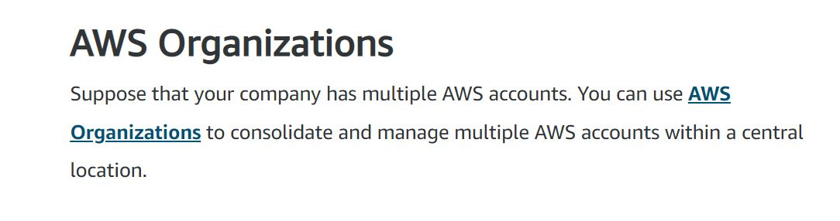

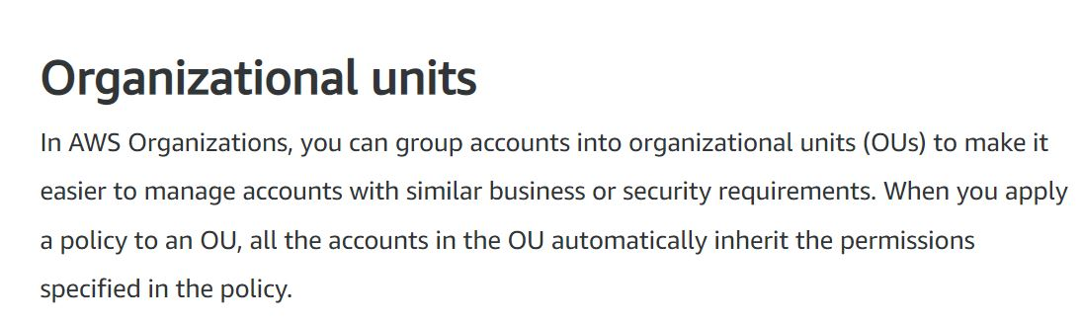

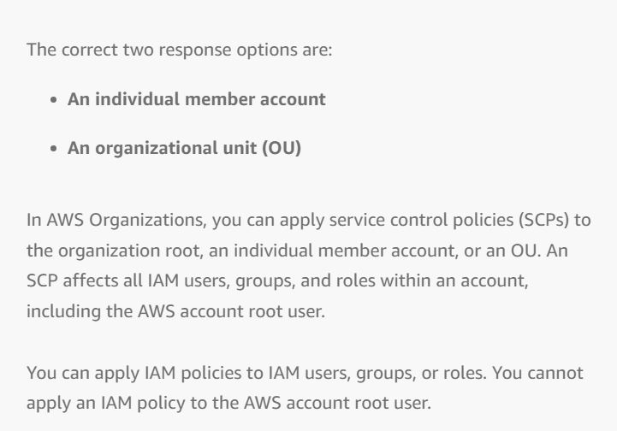

Compliance🡪 while using AWS you always need to take care of your buisnees need for example you want software which deals with consumer data then you must check it up with(GDPR) –General data protection regulation. In AWS you have full access to your data and you can take care of it the way you want.

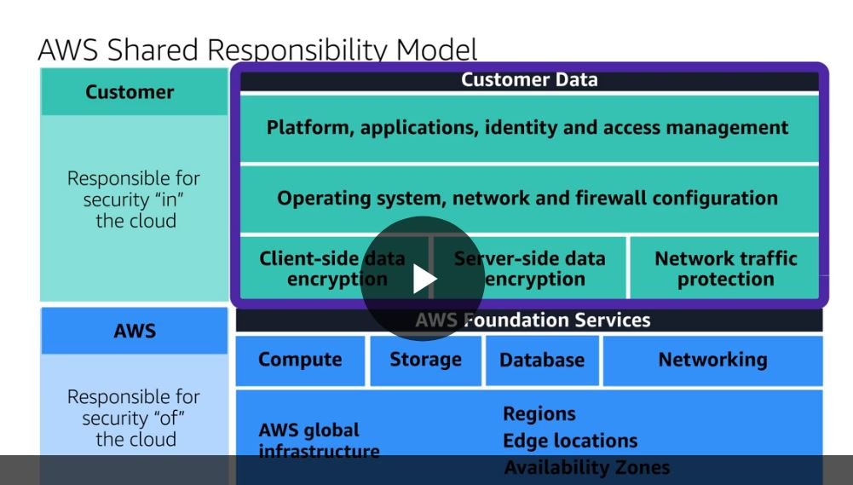

AWS provides multiple docs and paper which you can use as compliance reports.

You can complete these compliance using aws service using AWS Artifact.

Check AWS compliance to find all the compliance all at one place.

AWS follow the shared responsibility.

Beyond that what you build on AWS is upto you.

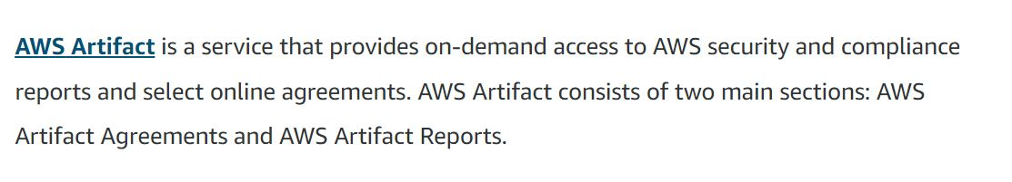

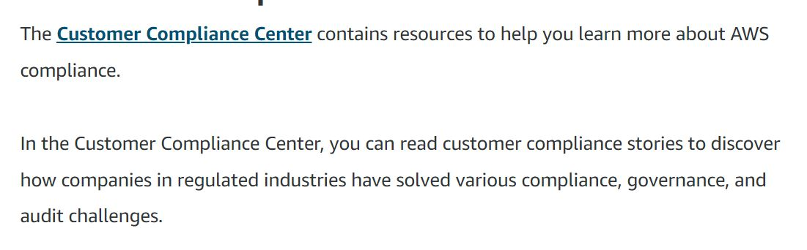

Distributed Denial Of Service(DDOSS)🡪it is an attack on your enterprise infrastructure

Objective of ddoS attack is to shut down your application ability to function by overwhelming system they can no longer operate.

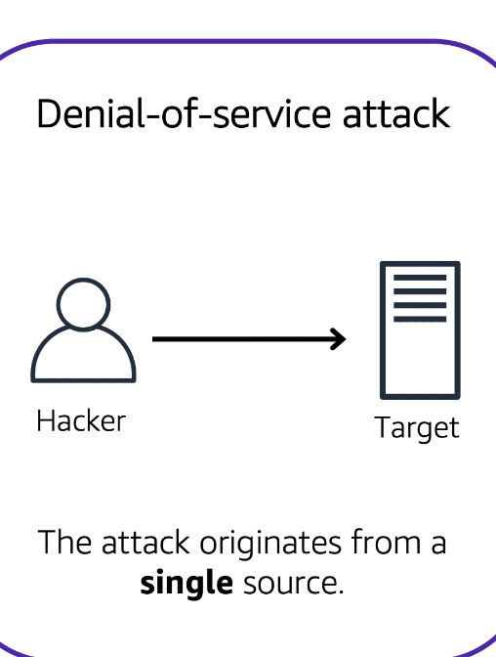

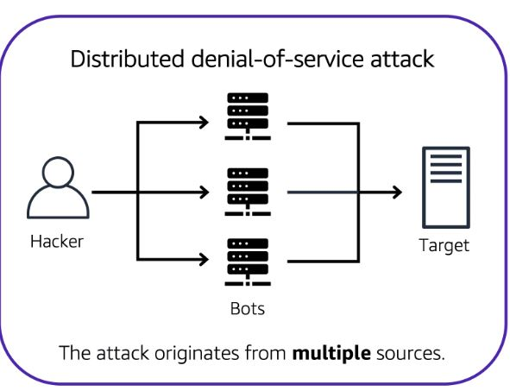

1.UDP Flood🡪in this bad actor gives the address of your application to the unknown application(weather ,all) and they will fill your application with unwanted data.

2.sloworis attack 🡪in this attack the user represents itself as having extremely slow internet connection, due to which other system cannot place their requests in between ,wating for the user to complete.’

3.HTTP LEVEl ATTACKS 🡪In these attacks the different users are asking for multiple things again and again ,all coming from zombified machines reducing the efficiency of systems.

Through AWS these all attacks are resolved automatically i.e. security groups are solutions for UDP floods means if the system is down, it must be protected by the security group.

You use entirely different protocol then the customer use. Security groups work at the network level not EC2 instance level, hence the instances are shrugged out of capacity.

It could not be said that no one can overwhelm AWS but scale it takes is very expensive for bad actors.

**For Sloworis attack** we have elastic load balancer which do not make it to reach instance until a complete packet is received.

It is highly expensive to hi jack such a big system since it works on the region basis.

For Sharpest Attacks Aws offers the system known as “**AWS SHIELD WITH AWS WAF ,**

**I**t has extensive Machine learning capabilities and can recognise threats as it evolves.

And can proactively defend your system against ever growing list of destructive actors.

If we have redshift service and SQL database we have Secure Socket Layer(SSL connection) to encrypt data and service certificates to authorise the client. and data is protected when passing between RedShift and Client. This functionality exists between numerous other AWS services. SQS, SNS, RDS and S3.

Amazon Inspector🡪helps you to improve security and compliance of your AWS deployed applications by running automated security assessments of your infrastructure.

In this A is Aws service and B is the client accessing the service.

When we connect with Amazon Redshift, we have SSL(secure socket layer) that is data is safe while passing between redshift and client.

This functionality exist in many other Aws services such as SQS ,SNS,s3,RDS and many more.

**Amazon Inspector**-these helps you to improve security and compliance of AWS deployed application by running an AWS assessment on AWS infrastructure.it helps to check deviation on best practices security infrastructure, exposure of EC2 instances,vulnerabilities and so forth.

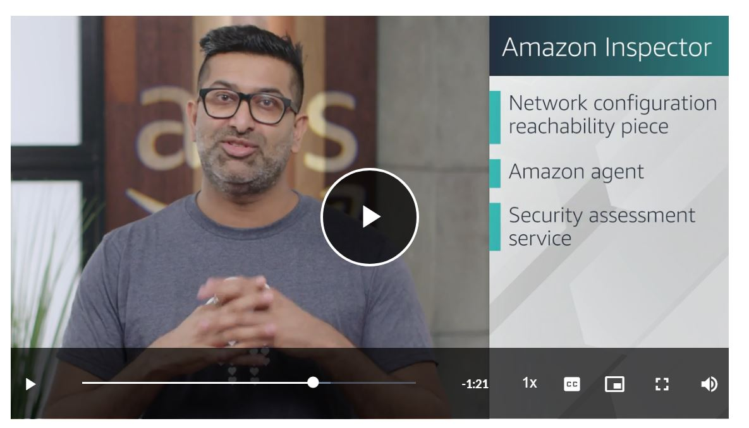

Another is Threat detection service i.e.

**Amazon GuardDuty🡪it anaylyzes** continuous stream of Metadata generated from your account and network activity. found an AWS cloud Relevance, Amazon VPC flow logs and DNS logs.

It uses integrated threat intelligence such as non malicious IP address, anamoly detection and Machine learning to identify threat accurately.it works independently on AWS services wont affect personality and availability of your workloads.

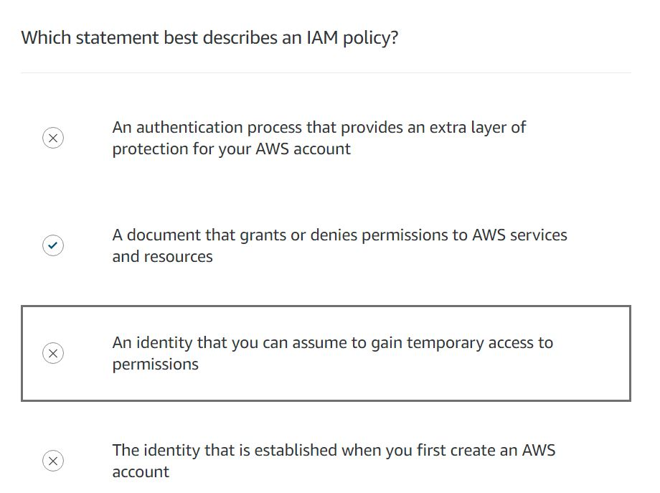

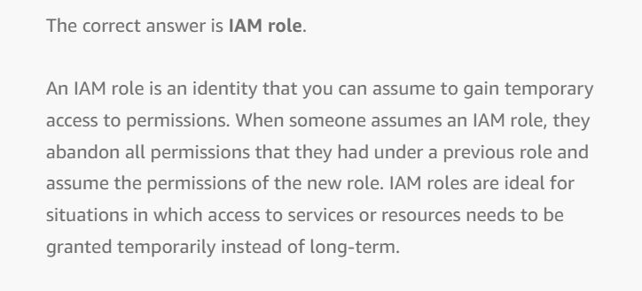

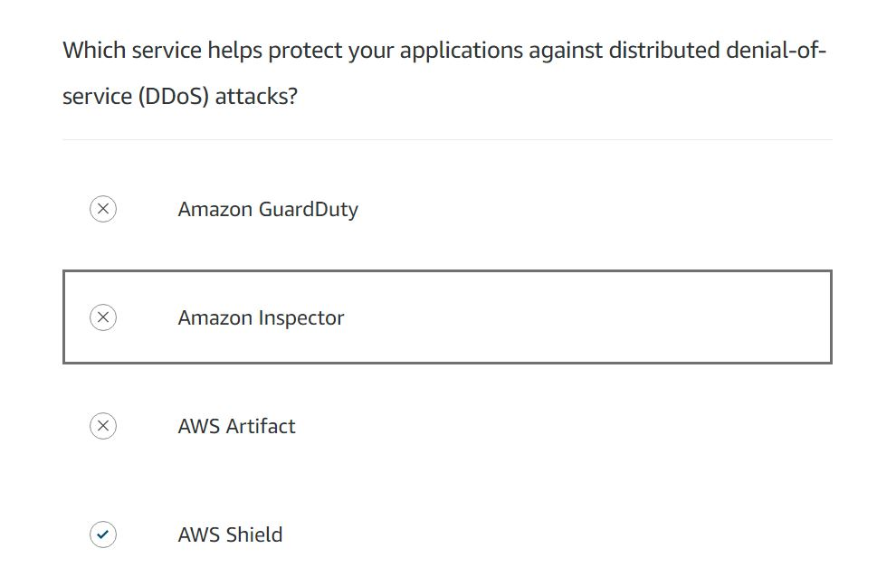

## Monitoring and Anaylytics 🡪

It is very necessary to monitor our systems on AWS clouds as it scaleup and down as per needs,its always important to put a checkon AWS system as per needs. For Example if one EC2 instance is overloaded you can trigger another scaling event to launch another EC2 instance.

Or if application is sending overalert msgs you can call employee to look whats going on.

## CloudWatch 🡪

Every machine has some limaitations and need to be looked upon after sometime ,you can set cloud watch alarm to check upon the condition of a machine which is bound to metric as certain metric is reached cloud watch can generate an alarm.

Cloud watch dashboard is used to list all the metrics that would list all metrics on the cloud.so that we can proactively monitor them.

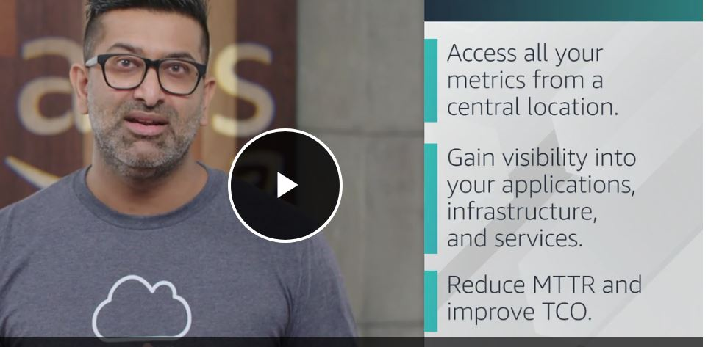

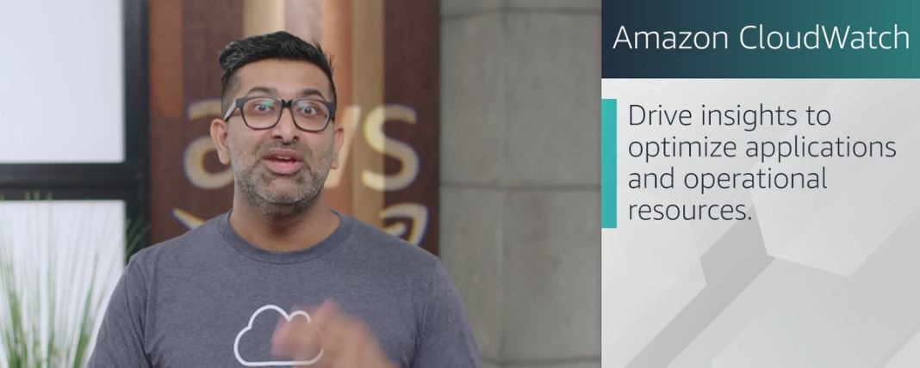

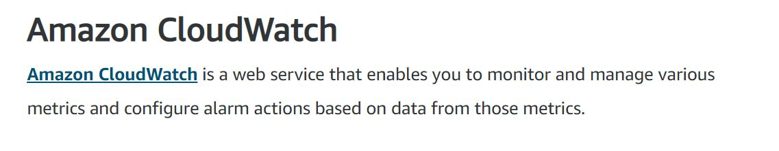

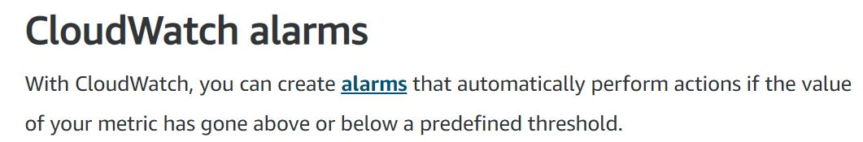

Cloud Trial engine 🡪 you have given all your responsibility of your data,tables and instances and all to AWS but it will be the case if some one works on data manually or data is affected in any other way, introducing AWS cloud trial which keeps check on the logs and we can check the logs when required.

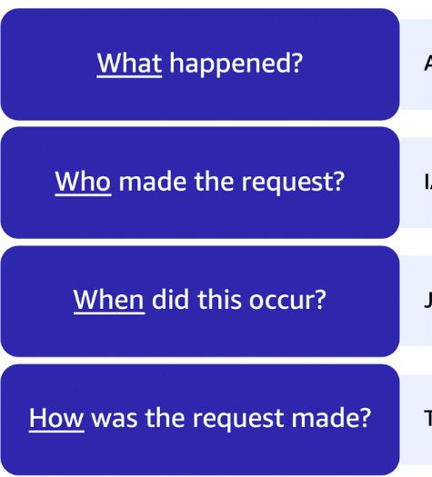

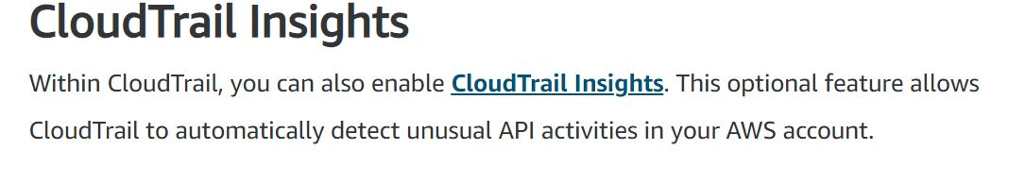

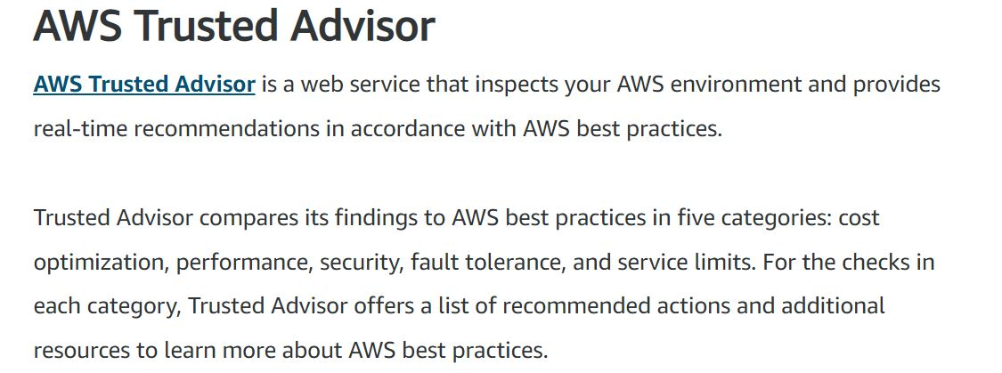

## **Pricing and Support🡪**

AWS free tier

1. Always Free.
2. 12 Months Free.
3. Trials2

AWS Lambda allows for 1 million free invocation per month. that means if you stay under 1 million invocation its always free.

This free tier never expires.

Amazon s3 is free for 12 Months for upto 5GB of Standard Storage.

AWS LightSail offers 1 month of trial upto 750 hrs of usage.

## **AWS Free Tier Services 🡪**

* Amazon SageMaker
* Amazon Comprehend Medical
* Amazon DynamoDB
* Amazon SNS
* Amazon cognito

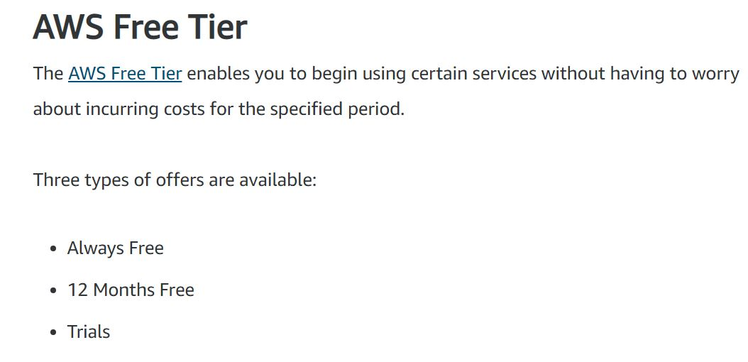

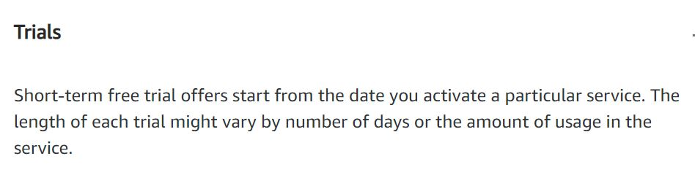

# **How AWS Pricing works🡪**

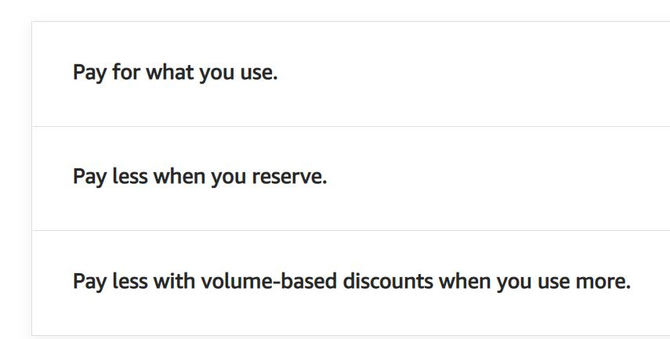

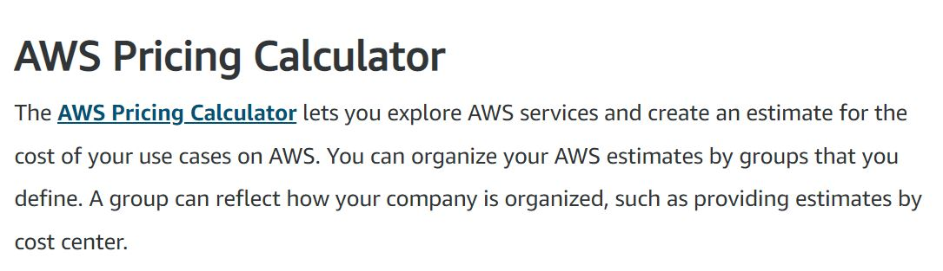

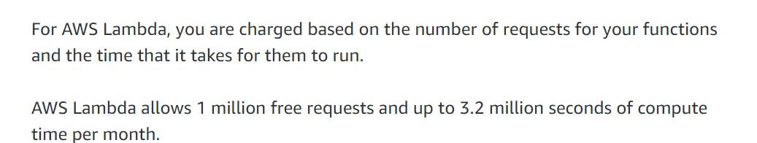

# Billing Dashboard->

AWS Management Console🡪go to billing section where you can find how much you spent and how much you want.

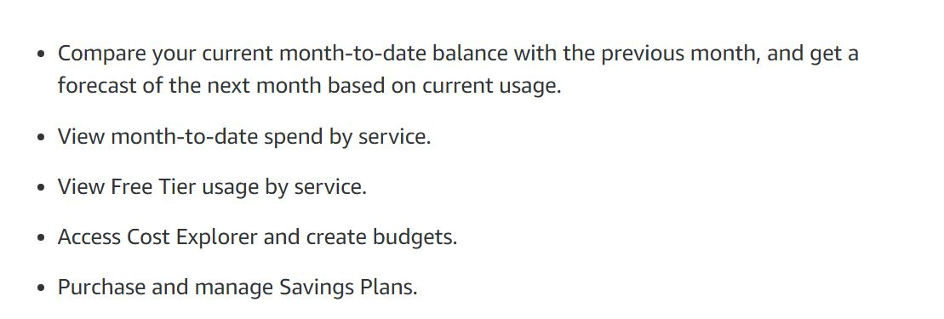

## Consolidated Billing-->

A Single Company can have multiple aws accounts, so it is difficult for the company to manage so many different accounts. Hence the concept of Consolidated billing which allows billing of multiple accounts in one bill.

It also allows reserve instances to be shared across organisation.

You can also get bulk discount ,because of all account in org and saving plans also.

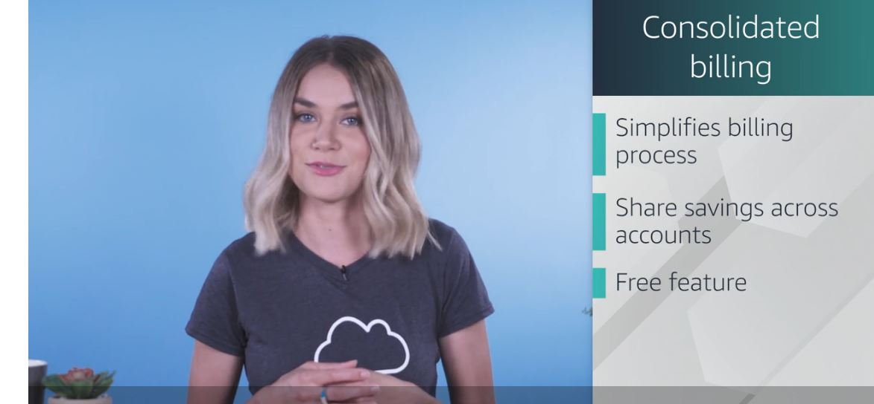

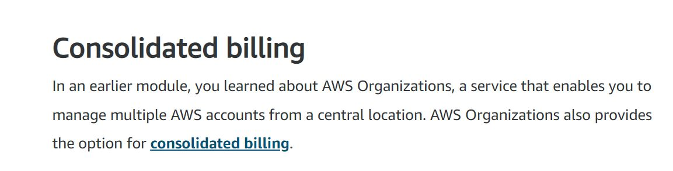

## AWS BUDGETS-->

Helps you to set your budget for the scenario with respect to cost and usage.it will create an alert when your cost or usage exceeds the budgeted amount. You can be proactively notified when you exceed your budgeted amount for resources

# AWS COST EXPLORER🡪

AWS have variable cost model, you only pay for what you use.AWS has an option for COST Explorer through which you can visualize ,how much money you are spending with AWS.it gives you the list of resources you are spending most money on, it gives you the 12 months historical data.

Cost explorer gives you some powerful defaults for reports, but you can build custom once as well. Cost optimization is priority, must be paying close attention to.

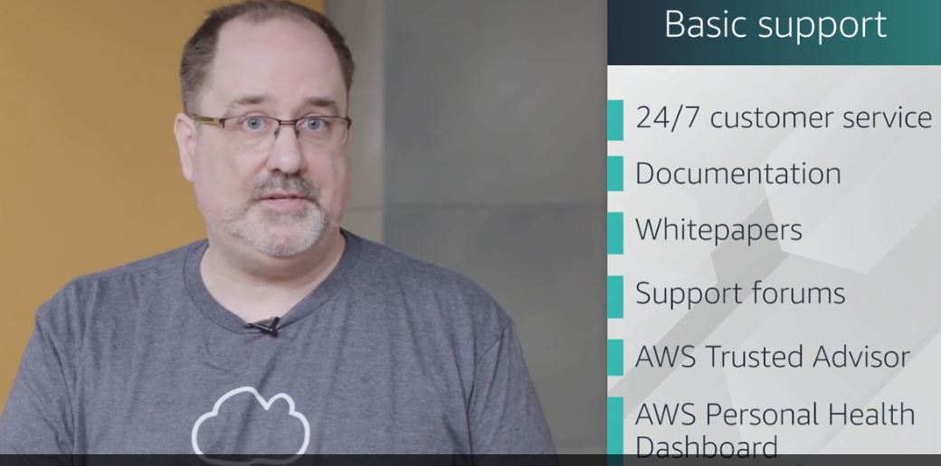

## **Developer Support🡪**

* Basic Support
* 24 hrs customer support for questions you have.

Buisnness Support

TAM work with customers to provide architecture reviews using well architectectured frameworks.

Architectures are checked on 5 pillars

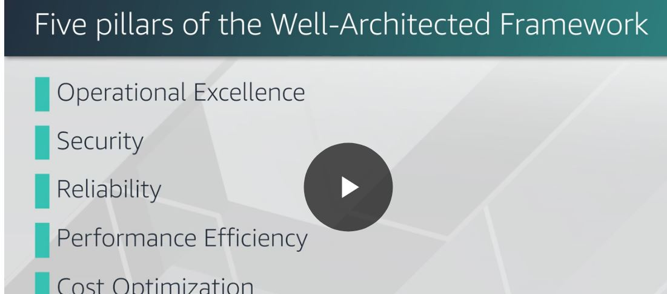

Job of TAM is much more than handling tickets.

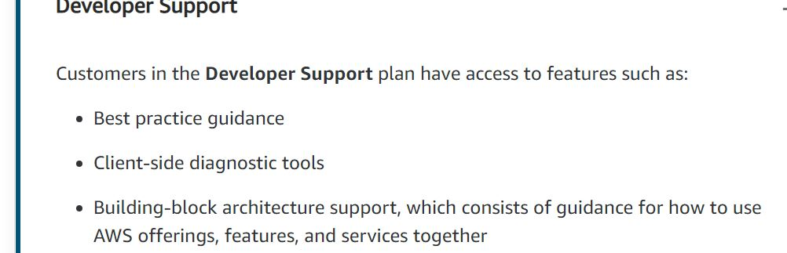

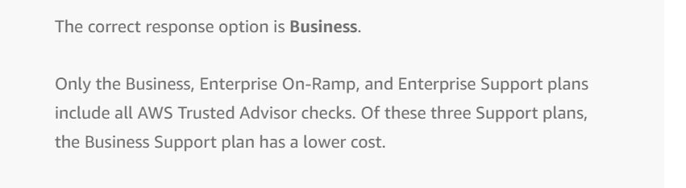

# **AWS MARKETPLACE🡪**

Is a curated catalogue that streamlines that run and deploy third party catalogue running on AWS architecture, this allows you to accelerate innovation.

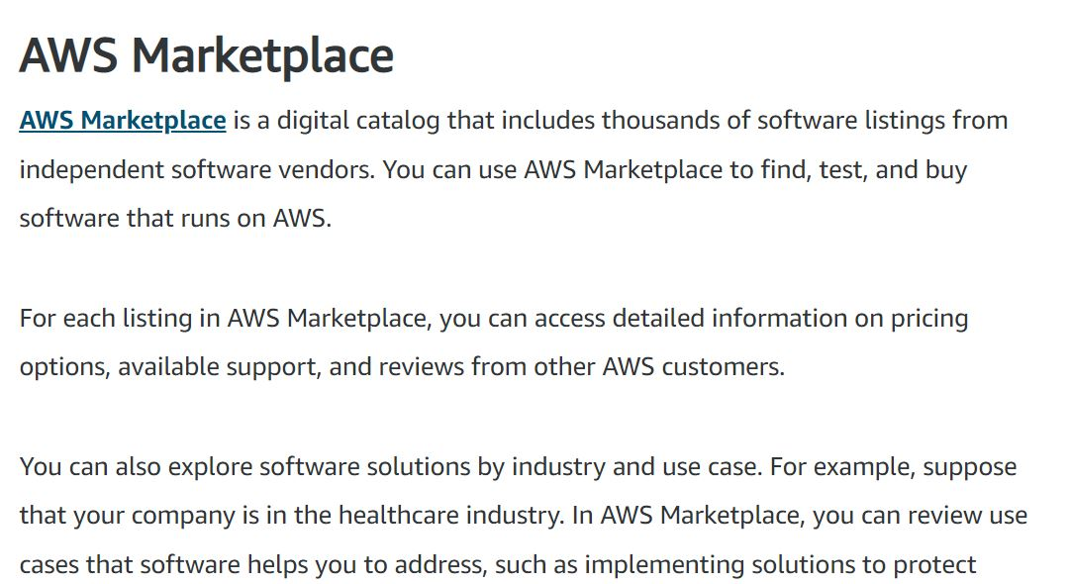

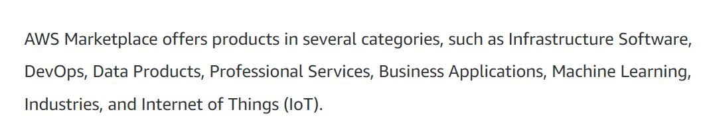

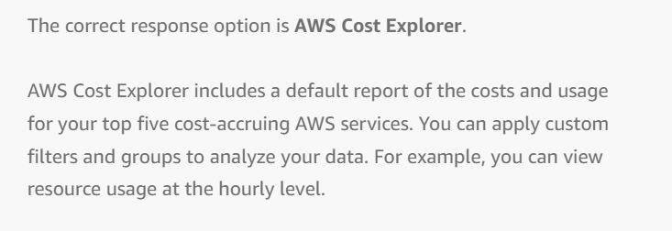

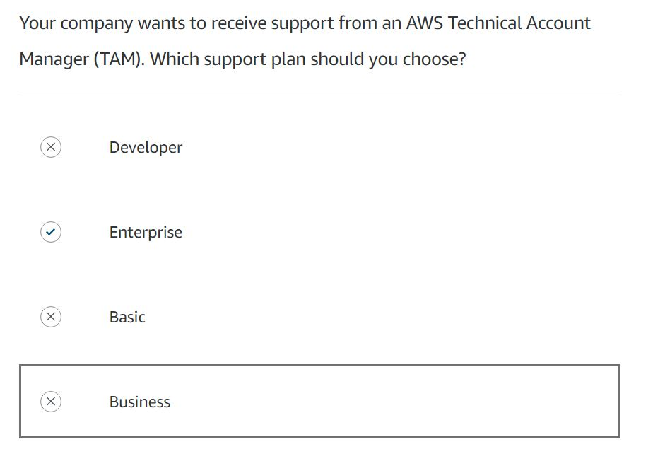

# Migration and Innovation🡪

Basically there can be situation in which the data can be on your on premises environment, so it is possible to shift your data from on-premises enivornment to AWS cloud.

## **AWS CAF(Cloud Adoption Framework)🡪**

It is not so easy to migrate to AWS, migrating to AWS takes lot of expertise.

AWS Experts have developed AWS CAF that help you to manage this process through guidance.it provides advice to your company for quick and smooth migration to AWS. Framework organises guidance into six areas focussed on different types of people you involve to migration. each prespective consist of different responsibilities covered by different groups.

Different Prospective for AWS are🡪

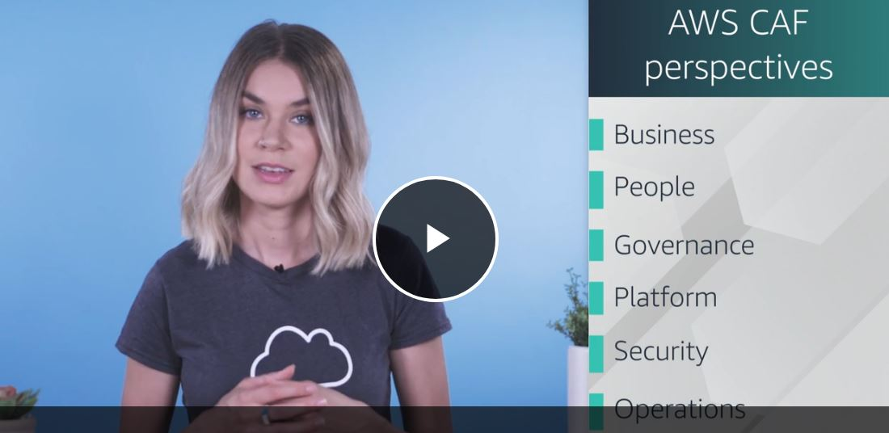

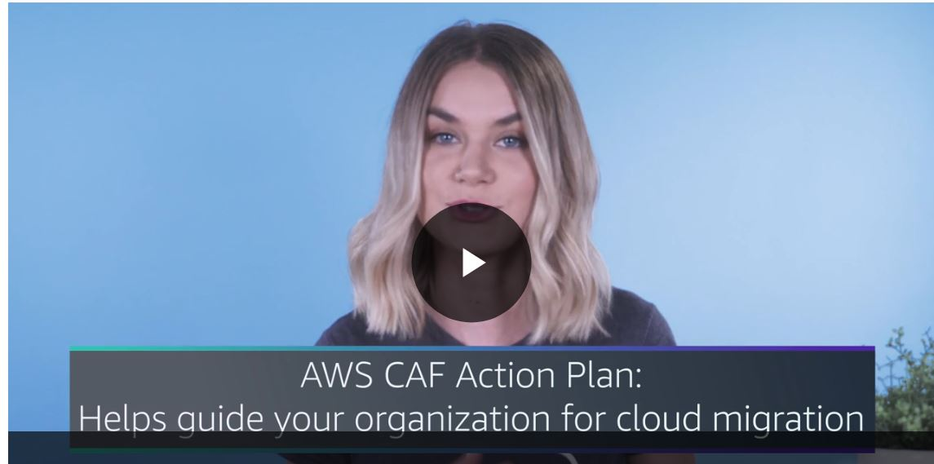

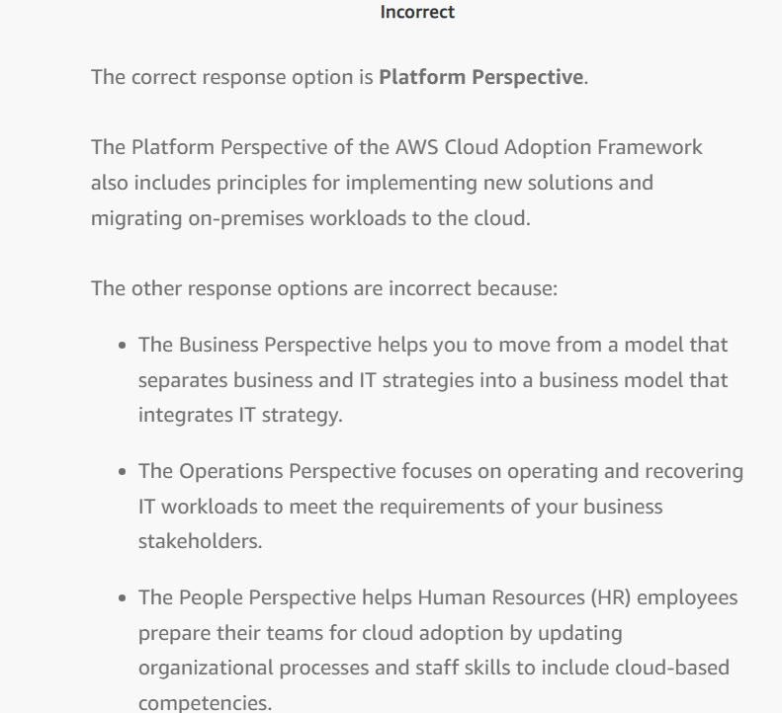

## 6R’s of migration🡪

Every application which is tightly coupled has 6 possible options when it comes to Enterprise Migration. we call it 6R’s.

## 6 paths to move to AWS

1).**Rehosting**🡪This is easy for businesses to do, because you are not making any changes, not pity much ,just pickup and move it to AWS. some companies found out that they can save upto 30% just by Rehosting.

2).Replatforming🡪 it is basically a lift and shift, you can make a cloud optimization in the process, no new dev efforts are involved here .you can take your existing mysql database and replatform it to RDS MySql. this give significant benefit to DBA team as well, it gives improved performance without any code changes.

3).Retire 🡪some of the parts of your enterprise are no longer needed. we found 10 to 20% company portfolios include application no longer being used. using migration to AWS can save significant cost of your company.

4).Retain🡪the application which are about to be deprecated , must not be moved to AWS as they could be deprecated ,where they are now or can be replaced by new one .

5.)Repurchasing🡪Common for company legacy for software vendors and get fresh start as a part of migration ,in this if your license is ending for previous vendor and you are migrating to another vendor, things take time as the some part of the things may work and some may not.

6.)Refactoring🡪this is driven by strong business need to add features or performance ,might not be possible on prem, now with in your reach, dramatic changes to architecture might be beneficial for your enterprise but this might come at highest initial cost in terms of planning and initial cost.

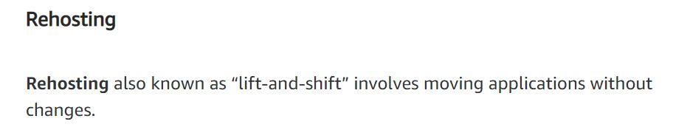

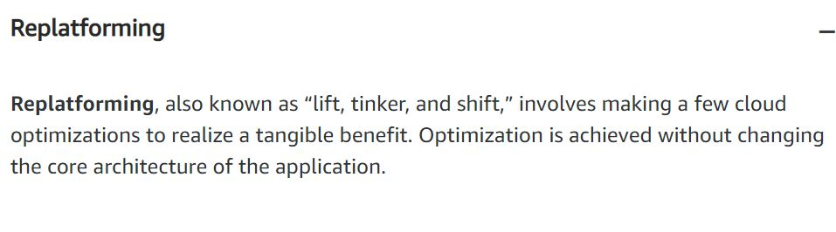

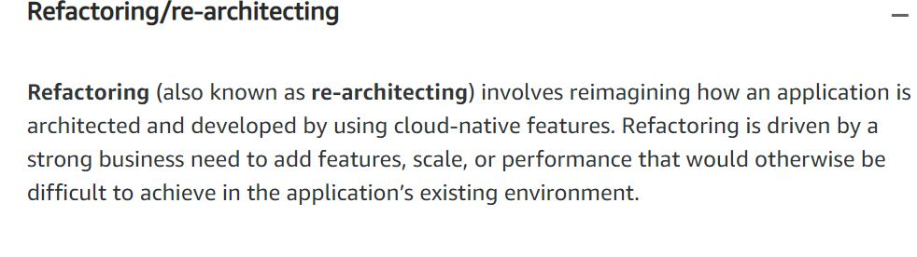

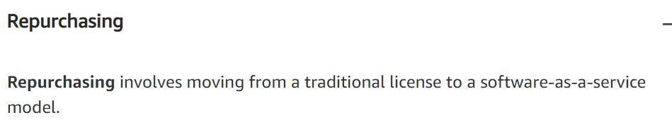

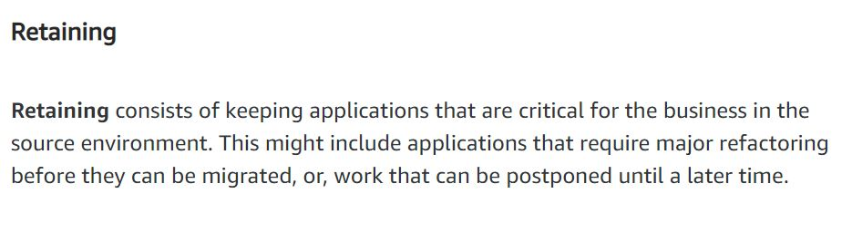

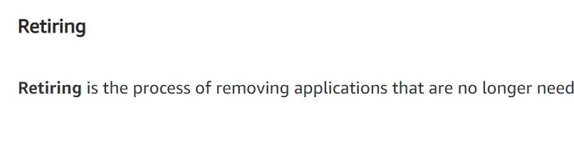

# AWS SNOW FAMILY

IN a scenario when you want to shift your data to aws ,it takes 1gbps speed ,1PB data transfer in 100 days,In real world it is slightly longer and at a higher cost.with this feedback we introduced AWS Snowfamily of devices

**AWS snowcore** 🡪can store 8TB data and supports edge computing(EC2 computing instances and IOT green gross).To obtain one you place order via AWS Management Console, we ship it you, you plug it in ,copy your data ship it back to us. We will copy data to your AWS account in s3 bucket you own.if 8TB is not enough .

**AWS SnowBall Edge**🡪it comes in two options snowball edge compute optimized option,snow ball edge storage optimized option.it can be fit in server and is used for greater computing needs such aws lambda functions,EC2 compatible EMI’s then and there or IOT compatible green gross to perform simple processing of data right then and there .consumers ship these to remote locations which is trickier for computing gpower lying around such as capturing of streams from IOT devices, image Compression,Vedio transcoding and

Largest AWS snowaMobile🡪45 feet ruggage shipping container, it houses **100 petabytes** and we come to your center andpull data to machine and deliver to AWS data center and paste it to AWS account .

All data stored in snow tools automatically encrypted in 256 bit encryption keys,owned and managed by you.

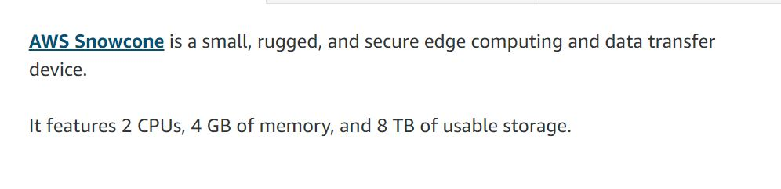

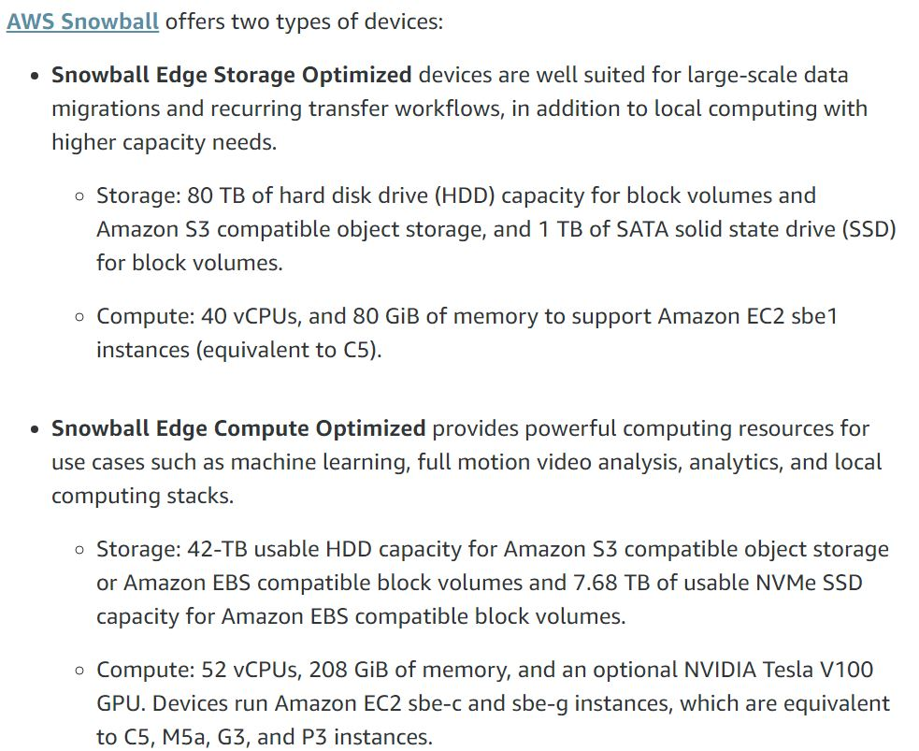

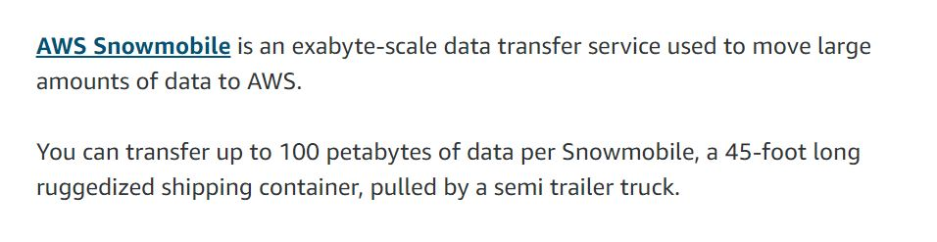

## INNOVATION WITH AWS

VMWare On AWS🡪 you can place your on premises VMWare on AWS,AWS has broadest of AI amd ML for your business.

Amazon SageMaker🡪**quickly build , deploy machine learning model at scale** or build custom models for all Aws popular frameworks.

Our Capabilties are built upon most comprehensive cloud platform,i.e high capability of Machine Learning and no compromises on the basis of security.

Amazon Augmented AI(A2I)🡪PROVIDE Machine Learning Platform that any builders can build upon without getting PHd level of expertise in house.

Other Solutions like Amazon LEX🡪heart of Alexa.

Amazon Textract 🡪used to fetch data from docs and lock them in repository.

AWS DeepRacer🡪chance for your developers to use Reinforcement learning, newest of Machine Learning Algo

AWS IOT🡪connect device all over world.

Aws ground station🡪use sateelite ,pay for time you need.

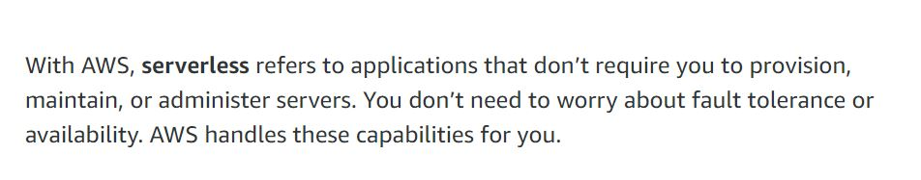

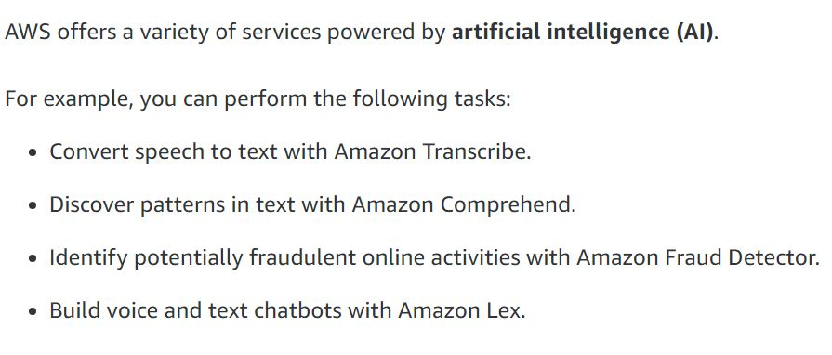

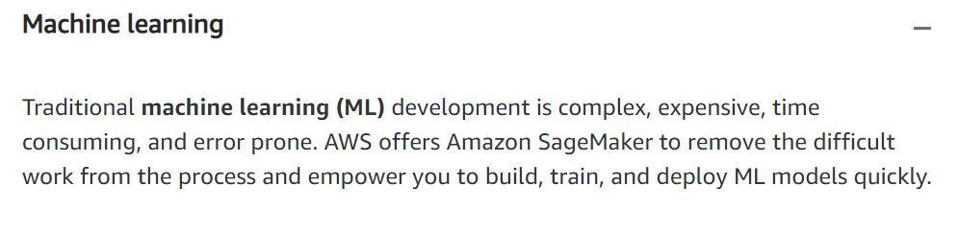

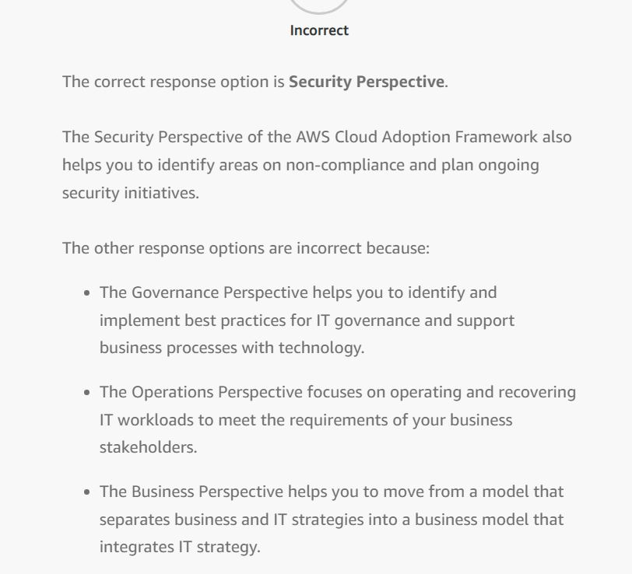

We use each AWS service as a building block for your solutions, there are endless architecture you want to solve while solving problem on AWS. you can string services together in an architecture.

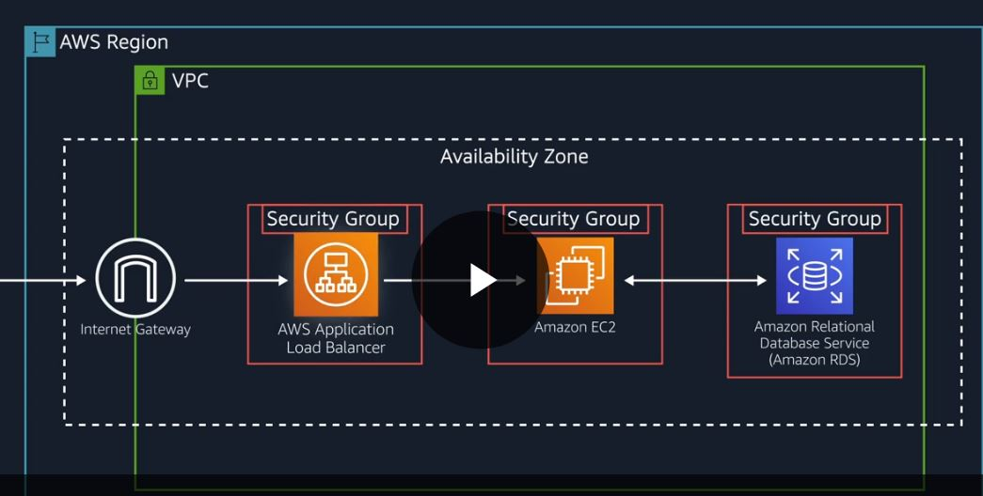

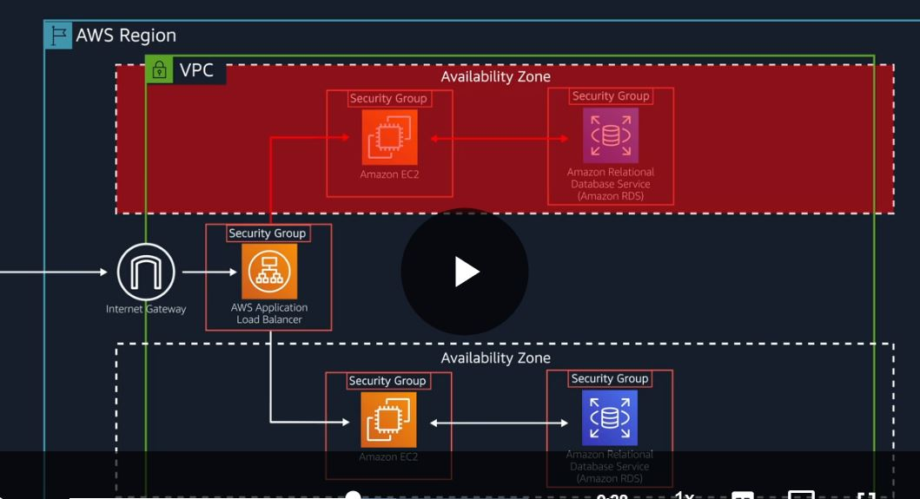

This architecture basically depends upon resources in different availability zones. if one AZ stops ,it will be depicted in second AZ as well.it is easy if you can spot efficiency in architecture as in simple example.

# **AWS-Well Architected Framework🡪**

Tool to evaluate the architecture you build for excellence in few categories

* Operational Excellence-focuses on running and monitoring the system ,to develop business values and continually running and improving the systems.
* Security-check integrity of data and protect system using encryption.
* Reliabilty-focus on recovery planning ,recovery from Amazon DynamoDB disruption or EC2 node failure ,how you handle change to meet customer demand.
* Performance Efficency-it intails using IT and computing resources efficiently.
* Cost Optimization.-looks at optimizing forecast , controlling way money spent.

The well architected framework is designed to enable architects,developers and uses of AWS to able to secure high performing ,Resilient and efficient infrastructure for the applications.

## **AWS Well Architected Tool🡪**

You can access via AWS Management console, create workload and generate AWS cloud. These are the areas tool is detected with potential issues,it gives plan plan you can establish with well architected issues.

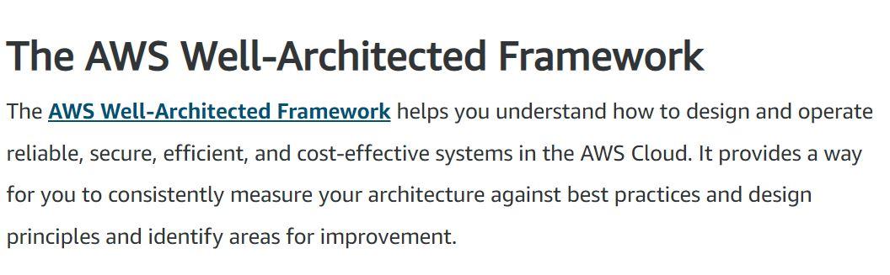

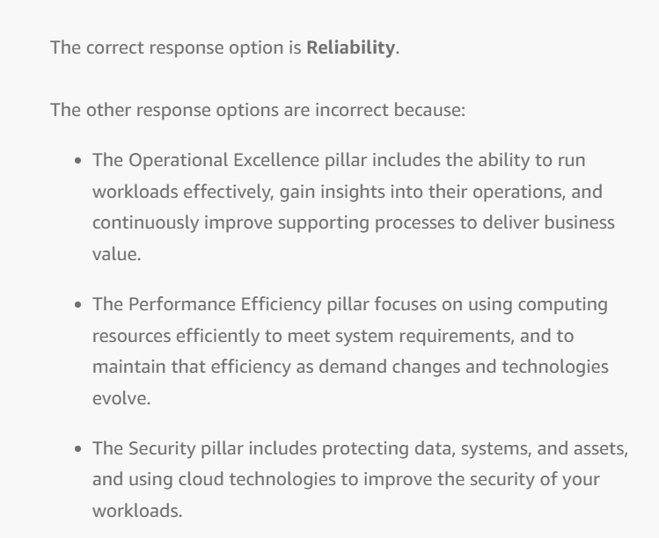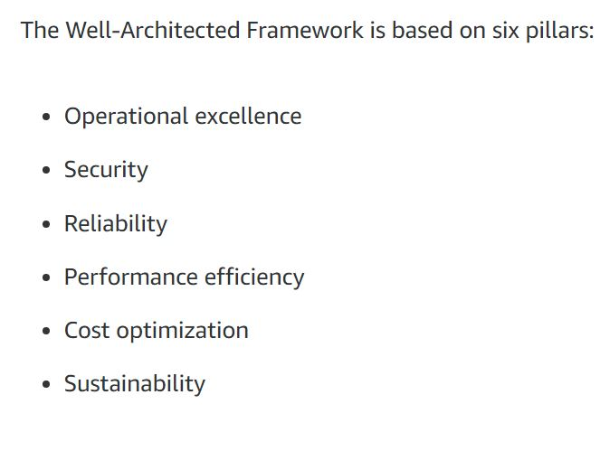

## **Benefits of AWS Cloud🡪**

In this course we have learnt about **AWS services**, the services offered by AWS.**AWS Termiology-** you must be well aware of the terminology used by AWS to go ahead in the journey of the cloud as well as **6 main benefits of AWS cloud w**hich are

* 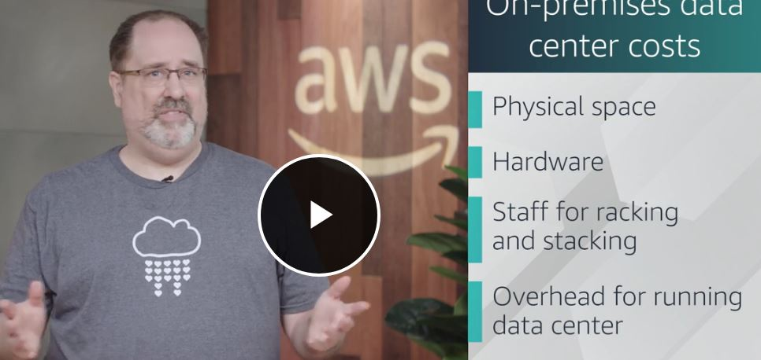
* Billing with AWS is fundamentally different, your bill with AWS vary month to month as you consume more or less resources, you can start small ,getting billed for what you use.
* If you are getting overbudget then you can start with

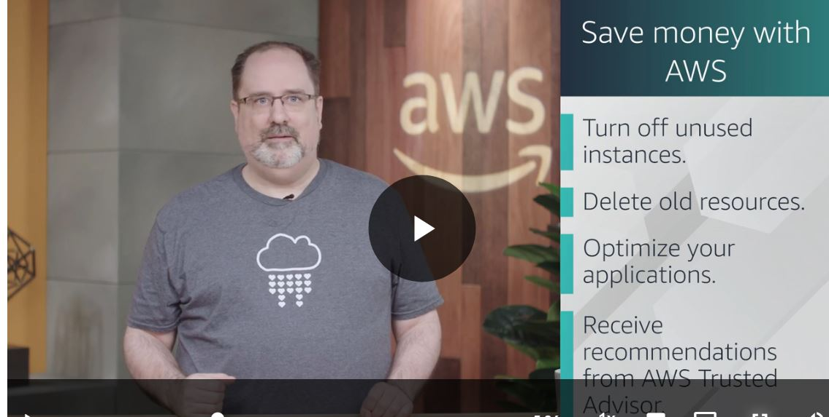

# Benefits of Massive Economies from scale🡪

AWS is building large number of data centers all around the world, in order to build hardware Aws is buying massive volumes of hardware.AWS is expert at building efficient data centers. because of which you could run data center of own.

# Guessing the capacity 🡪

You can build your capacity as per needs you build your datacentre but as per Aws you have to pay as per your need.

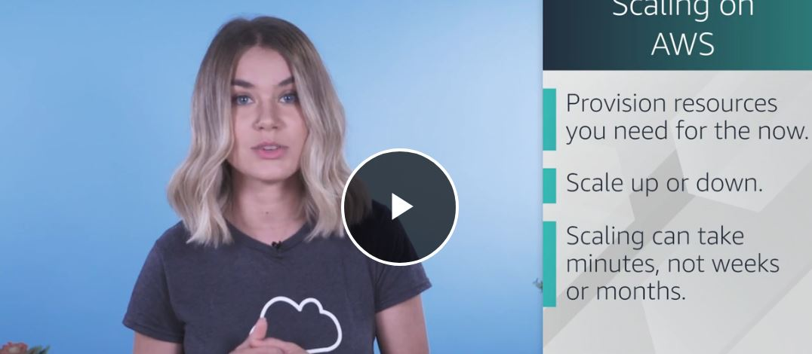

# Speed and Agilty🡪

You can easily try everything on Aws easily , you can delete resources as per your need.it actually takes.

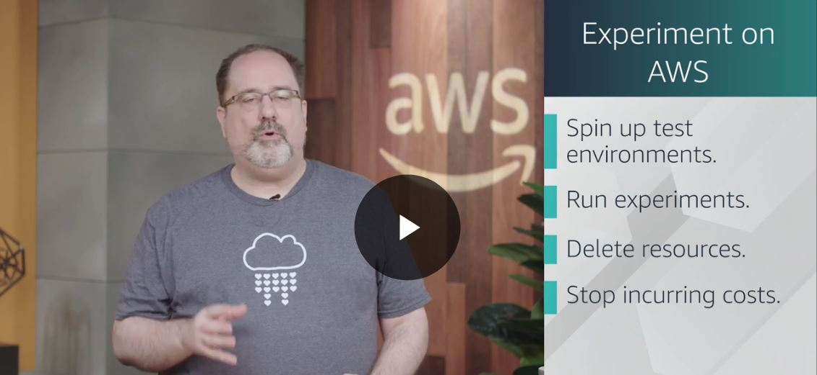

In datacentre cost of experiment failing is high, because you bought the server. The flexibility of AWS helps drive innovation.getting db on premises might take weeks but on Aws it takes minutes.the speed helps you to get upto market quicker.

If you are a software company why you spend time and money on maintaining datacenters ,through AWS you can expand your business easily i.e if you want to expand your business from US to Germany,it can be done into minutes using Aws cloud formation but if you do it traditionally it will take months and years.

